This document is meant to assist you with creating and submitting a Cash Advance Request for travel or expenses. However, there are factors to consider before you submit a Cash Advance Request.
Travel Advances being phased out with New Travel credit card program in place
Financial Services, in collaboration with Strategic Procurement Services, will be enforcing the Travel and Expense Reimbursement Policy, which states that “Faculty and Staff will not be issued travel advances for costs that can be paid for through a Queen’s TCard”.
Effective October 11, 2022:
- Cash/travel advances will no longer be approved for expenses that can be charged to a T-card or P-card, such as: rail, airfare, hotel accommodations, rental vehicles, registrations etc. However, if you can prove that you have applied and are waiting for a TCard, your advance may be approved.
- Faculty and Staff must use the segments feature in ERS when requesting an eligible cash advance otherwise the advance will not be approved. Any expected expense.
- If funds are needed for countries that credit cards are not used, you must complete segments outlining these costs.
Effective January 1, 2023:
- The expectation is that you have applied and received your Queen’s TCard. Cash advances will be rejected for all expenses that can be charged to a TCard or PCard, such as: rail, airfare, hotel accommodations, rental vehicles, registrations etc.
- Faculty and Staff must use the segments feature in ERS when requesting an eligible cash advance otherwise the advance will not be approved.
- If funds are needed for countries that credit cards are not used, you must complete segments outlining these costs.

Creating a Cash Advance Request
To create a Cash Advance Request, you will need to log into ERS (for more detailed information please see the “ERS Frist Time Users Guide”).
www.queensu.ca > Search and SignIn > MyQueen’sU – SOLUS, MyHR and more.
Scrolls down to the Financial Applications section and select the ERS Icon then “Log into ERS”.
- Once in ERS go to the ‘Request’ tab.

- Under the ‘Request’ tab select the red ‘Create New Request’ box.

- The ‘Create New Request’ window will open. You will need to enter in all fields marked with a red asterisk *.
  - ‘Request Name’ should have the reason for the Cash Advance. Your department may have a preferred format.
  - ‘Travel Start Date’ should be the day travel will begin or if this is for expense the day the purchase will be made.
  - ‘Travel End Date’ should be the day that the trip will be concluded/the day you will arrive home or a day or a few days after the purchase is made allowing time for the purchase to be processed.
  - ‘Business Purpose’ field should be more descriptive. Enter the expense that this request is to cover.
  - ‘Research Project Code’ will have to be provided by your department or the Principal Investigator of the project. If this advance request is not attached to a project enter 000000.
  - ‘Travel Destinations’ should be the city you will be traveling to. If you will be visiting multiple location, use the first destination.
  - ‘Comment’ is not a required field but is suggested that you add a short explanation to avoid confusion and delays.
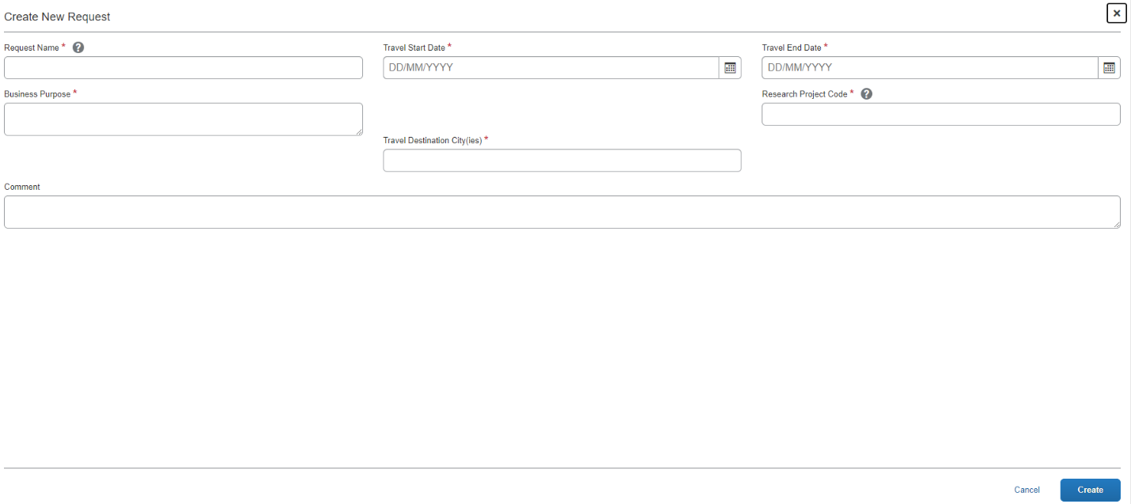

- Once all the required information has been entered select the ‘Create’ button.
- The ‘Expected Expenses’ screen will open. You are required to add at least one expected expense, to the cash advance request.
  - You will need to create an ‘Expected Expense’ showing how much each expense will be, these can be entered in groups such as flights, hotels, meals, car rentals etc.
- To add an ‘Expected Expense’ go to the ‘Add’ drop-down button.

- There are several expense types to choose from, they are similar to what you will see when creating an expense claim but more streamlined.
- Once you have selected the expected expense that you wish to use it will open in a new window. The required information will be marked with a red asterisk *. Fill in these fields and then select the ‘Save’ button in the top right corner to be taken back to the main request page.
- Repeat as needed.

Example of Miscellaneous Expected Expense

- After you have created all ‘Expected Expenses’ ensure that the ‘Total’ on the main request page is the total amount that you want to request. The amount shown is the payment that will be processed.
These amounts show the total amount of the cash advance that you are requesting.

- Go to the ‘Request Details’ drop-down menu. From the list select “Add Cash Advance. IF THIS IS NOT DONE- NO FUNDS WILLL BE ISSUED

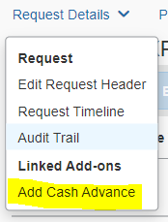
12. You will be taken to a new page where you will see a box “Cash Advance Amount”, enter the total amount of your expected expenses into this box. Please ensure that the currency is left as Canadian Dollars.

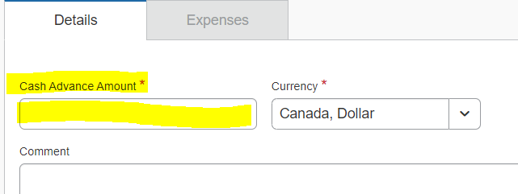

13. Click the “Save” button in the top right corner of your screen.
14. Go to the ‘Request Details’ drop-down menu. From the list select ‘Request Timeline’.

15. The ‘Request Timeline’ window will open.
16. On the left-hand side, you will see a column titled ‘Approval Flow’ and a small blue ‘Edit’ button, select it.

17. The ‘Edit Approval Flow’ window will open.
18. In the field labeled ‘Manager Approval’ enter the LAST name of your approver, then select them from the list generated. This will activate the ‘Save’ button, select it and you will be taken back to the ‘Request Timeline’ page and your approver will have been added.
  - If the last name is hyphenated you may have to search with and with-out the hyphen, re-arranging the last names or by each last name separately.
  - If you cannot find your approver, please contact Anthony Boese at ajb19@queensu.ca.

19. On the ‘Request Timeline’ page ensure that you have the correct approver then select the ‘Close’ button in the bottom right corner.
20. You will now be back on the main request page and can submit the request for approval and payment. In the top right corner is the orange ‘Submit Request’ button. Select it.

21. Your request will be submitted to your approver for review and then sent to Financial Services for final review and payment processing.

Cancelling a Request
If you need to cancel or recall the request, go to the ‘Requests’ tab. Please note that once you cancel a request it cannot be resubmitted.
Select the request. When it opens click on the blue ‘Cancel Request’ button in the top right corner.

The ‘Cancel Request’ window will open, you will be prompted to enter in a comment, but it not required. Select the blue ‘Okay’ button.
The ‘Cancel Request’ button will be replaced with and orange ‘Close/Inactivate Request’. Since you cannot resubmit this request, select this button to remove the request from your account. This will reduce confusion later when a new request is created and submitted.
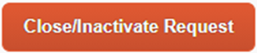

A window will open asking you to confirm that you want to Close/Inactivate this request. Select ‘Okay’.
Accounting for Or Returning a Cash Advance
When the travel is completed to the item has been purchased the cash advance will have to be accounted for and any unused funds returned to the University.
For detailed information on accounting for a cash advance as well as returning any unused funds please see the “Accounting for a Cash or Research Participant Advance’ document on the Financial Services website.

If you would like more detailed information on a specific section or require clarification, please contact expenses@queensu.ca.

