If a claimant received a cash advance for travel, expense or a research participant advance and the trip or purchase was cancelled, the total amount was less than the amount of the cash advance, or the research participant payment advance was not fully utilized; the claimant must return the unused amount to Financial Services.
There are three methods that can be used to return the Funds:
- Payment by cheque/money order sent by inter-office mail to Financial Services – the receipt that is attached will be signed, scanned, and emailed to the claimant. The claimant will then attach the emailed receipt to the expense line-item Cash Advance Return, (as proof of repayment) in the expense report created in ERS.
- Payment by cash/cheque/money order submitted in person to Financial Services – the receipt for the cash/cheque/money orders will be signed by Financial Services and a copy given to the claimant/delegate. The claimant/delegate will then attach a copy of this signed receipt (via scan or photo) to the expense line-item Cash Advance Return, (as proof of repayment) in the expense report created in the ERS.
- Payment by bank transfer – to initiate a bank transfer for repayment please contact travel.advances@queensu.ca. You will be sent an email and instructions to follow. The emailed notification that the funds have been received can be attached to the expense line-item Cash Advance Return (as proof of repayment) in the expense report created in ERS.

Creating an Expense Report
- Log into ERS (for more information please see the ERS Frist Time Users Guide):
  - www.queensu.ca > Search and Sign in > MyQueen’sU – SOLUS, MyHR and more > Finance Applications > Expense Reimbursement (ERS) > Log into the ERS.
- Go to the Expense Tab.
- Select the “Create New Report” box (for more information on creating a claim please see the “Procedure – Create an Expense Report” document).
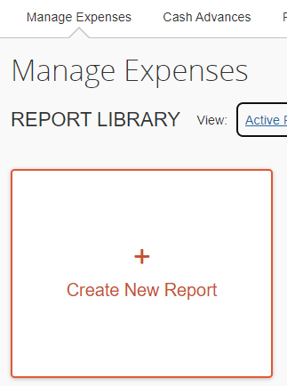

- Click on the “Create From an Approved Request” link in the top left corner.
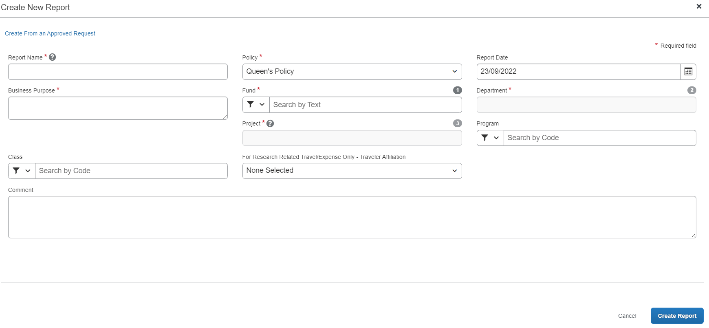
- A window “Create From an Approved Request?” window will open asking you if you want to continue, select the “Create From an Approved Request” button.
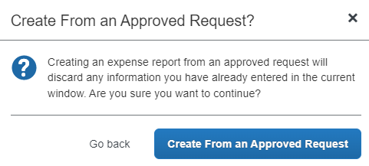
- A window will open listing your active cash advances.
- Select the cash advance you want to assign to the claim and the “Create Report” button in the bottom right corner.
- Your claim will be created. A box will show the amount of the Cash Advance that was been assigned to the claim.

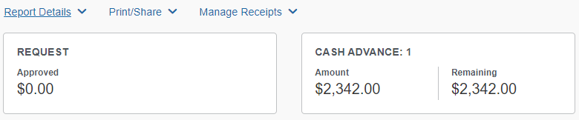

  - The Amount column is the total amount of the advance.
  - The Remaining column shows the amount advance that has not been accounted for.
- Add expenses as you normally would. Once all expenses are added, if there is an amount under “Remaining” column this the amount will need to be returned.
- Return the funds using one of the methods noted above. Then attach the receipt provided to expense line “Cash Advance Return” under section 13. Cash Advance.
- You will be required to enter the date and the amount that has been returned as well as attaching the receipt that was provided as proof of payment.
- Once this has been completed you can submit your claim for approval using the normal process.

If you did not assign the advance to the claim or had a research participant advance to the claim, you can add it once the claim has been created, even if you have already added all the expenses:
- Go to the “Report Details” drop down menu.
- Under the “Linked Add-ons” select the “Manage Cash Advances” link.
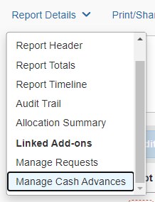
- A window will open, select the “Add” button in the trop left corner of the window.
- A window will open listing your active cash advances, select the one that you want to add to the claim.
- The “Add to Report” button will become active. Select it.
- You will be taken back to the “Cash Advances” window, select the “Close” button in the bottom right corner.
- The advance will now be assigned to the claim, and you will see the “Outstanding Advance” should now be $0.00.
- Compete the claim as noted above.

For more information, please contact expenses@queensu.ca

ERS – Cash Advance Return Receipt

UNUSED CASH ADVANCE REPAYMENT RECEIPT
Received from:

Name: ___________________________ Employee ID: ___________
Cash Advance Name (or Key): _________________________________
Amount: $________ Paid by: ☐ Cash (Do NOT send cash by inter-office mail)
☐ Cheque #________
☐ Money Order
Signature:________________________ Date: __________________

This section for Financial Services use only
Received by: Financial Services

Name: ____________________________
Position: ____________________________

Signature: ________________________ Date: __________________

Email ___________________________________
Please include your email so we can send you a copy to attach to your claim

NOTE: Please scan and attach to your expense report after it has been signed by Financial Services.

