Copying an Expense Report can be done for two reasons, the process will be the same for both reasons:
- There was an issue with the previously submitted claim, item not paid, or payment was not process correctly.
- Copying a claim that was submitted to clear a T-Card, then adding the rest of the expense to the claim to link them together.
Issue with a previous claim
If you had previously submitted a claim and there was an issue with the processing, such as item that was marked as Personal and not reimbursed and should have been, the claim can be copied, and adjustments made.
Before you copy and re-submit a claim, please contact expenses@queensu.ca to investigate the issue with the claim or the payment.
T-Card
With the launch of the T-Card two or more claims can now be submitted for a trip. If a flight is booked months before the travel time it can be submitted so the T-Card can be cleared, and the claimant is not charged any late fees.
When the rest of the expenses are submitted for the claim, it is asked that the original claim, i.e., for the flight, be copied and adjusted. By copying the original claim, it links the two and can help to reduce confusion.
This is not required but suggested and may not always be possible if there is more than one expense claim that was created for previously submitted T-Card Charges.
Process for Copying an Expense Claim
- In ERS go to the Expense Tab:

- Go to the Manage Expenses Sub Tab:

- Under the Manage Expenses header you will see a drop-down menu showing “Active Reports”:
- Select from the drop down list the best option to find the claim.
  - Using the “Date Range” option will allow you to search for claims that are over a year old.

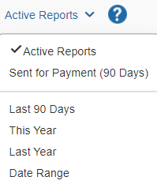

- Select the claim you wish to copy and open it.
- In the top right corner, you will see the “Copy Report” button, select it.

- A new window will open asking for you to enter a Report Name. You can enter the name as “Copy: (previous report name)” or create a new name. you can also change the date of the claim, this is not recommended because it can cause issues when adding expenses.
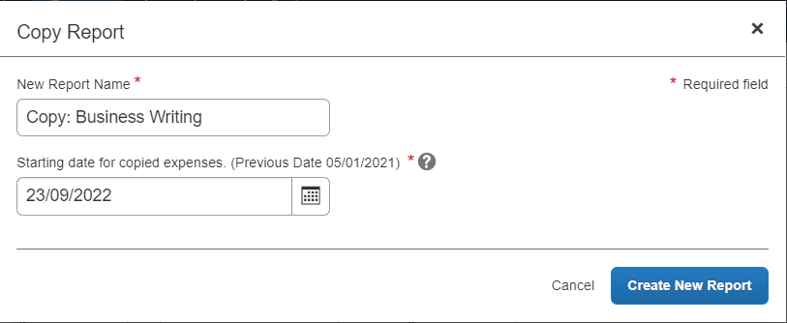
- Once you have entered a Report/Claim Name select the “Create New Report” button.
- The copied claim will open with all previously entered expenses attached. You will be able to edit the expenses that were copied over.
  - NOTE be careful with amounts, you may have to adjust to $0.00 so you are not reimbursed a second time.
  - If re-submitting a claim with a T-Card expense, the amount should be changed to $0.00 so it is not paid a second time.
- It is asked that you add a comment to the claim that it is a copy and why. To do this go to the Report Details drop down menu and select the Report Header option.
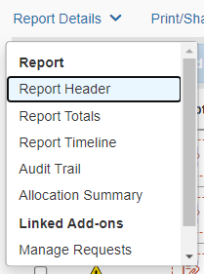
- When the Report Header opens there will be the section at the bottom allowing you to enter in a comment. Once you have added the comment select Save.
- If required, add in new expenses in the normal manner.
- Submit the claim in the normal manner.

For more information, please contact expenses@queensu.ca.

