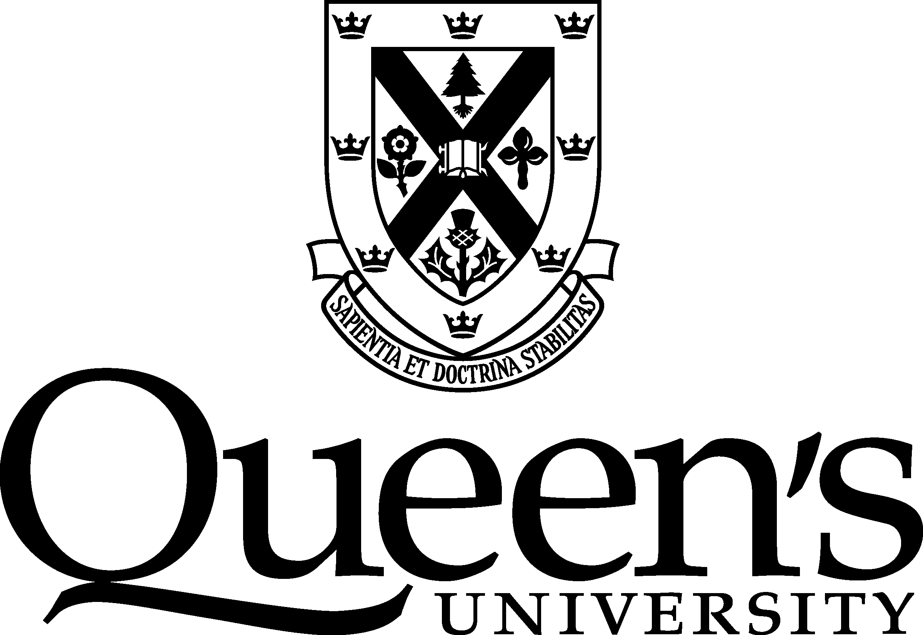

MINUTES
Vice-Provost (Teaching and Learning)
Meeting: | Academic Integrity Roundtable | Date & Time: | March 16, 2021  10.00 – 11.30 a.m.
Location: | Online
Chair: | John Pierce, Vice-Provost (Teaching and Learning)
Members  Present: | - Pam Briand (FAS)  - Tracy Brons (FEAS)  - Rebecca Carnevale (Education)  - Monica Corbett (SGS)  - Kody Klupt (SCAD Delegate)  - Marianna Kontopoulou (FEAS) | - Susan Korba (Student Affairs)  - Alana Korczynski (DBMS)  - Patrick Oosthuizen (SCAP Delegate)  - Harry Smith (Smith School of Business)  - Nancy Somers (Law)  - Sue Fostaty Young (CTL)
Observers  Present: | - Lavonne Hood (University Ombudsperson)  - Matthew Mellon (AMS Exec) | - Mark Swartz (University Librarian Delegate)
Administrative  Support | - Claire O'Brien (Office of the Provost & Vice-Principal Academic)
Regrets | - Missy Chareka (Arts and Science), Leslie Flynn (Health Sciences), Shikha Gupta (SGPS), Lon Knox (University Secretary), Anthony Lomax (SGPS), Anna Taylor (BISC)
Guests | - Melissa Seal (Legal Counsel)  - Denise Stockley (for Leslie Flynn) (Professor and Scholar in Higher Education)  - Sue Blake & Gillian Ready (Office of the Provost & Vice-Principal Academic)

Opening
Before the meeting was called to order, the Chair acknowledged Queen’s University’s presence on the traditional lands of the Haudenosaunee and Anishinaabe peoples.

A round of introductions was made.

- Agreement on the Agenda

It was agreed to accept the agenda as circulated.

- Agreement on the Minutes of March 5, 2020

It was agreed to accept the minutes of March 5, 2020 as circulated.

- Chair’s Report
The chair noted that a new position of Academic Integrity Coordinator was being created in the provost’s office. The coordinator’s functions will include providing training for faculty members, promoting the value of integrity to students, and researching an online system for handling paperwork around departures from academic integrity.

Claire O’Brien reported on the recent International Centre for Academic Integrity conference, including examples of good practice that had been shared around educative approaches to sanctions for academic dishonesty, and on dealing with students accessing answers on sharing sites such as Chegg and Course Hero. Notes from various sessions were circulated with the agenda.

The chair drew attention to the summary of a recent survey of students across Queen’s on academic integrity conducted by Kelley Packalen and Kate Rowbotham of the Smith School of Business. Numerous interesting findings from the survey are being developed into research papers by Drs. Packalen and Rowbotham. The survey reveals that the majority of departures from academic integrity are being handled informally, outside of the official procedures. This is problematic from a procedural fairness point of view and can mean that students who depart from academic integrity more than once are not being sanctioned appropriately. He urged faculties and schools to encourage faculty members to use the academic integrity procedures of sending a notice of investigation, meeting with the student or considering a written response, then making a finding of departure from academic integrity if appropriate.

Finally, the chair drew attention to the list of academic integrity modules for students that he is aware of across Queen’s. He asked members to let Claire O’Brien (claire.obrien@queensu.ca) know if they were aware of any other modules, and noted he hoped any further developments could be made cooperatively. Susan Korba noted that SASS is revising and augmenting its module for Fall 2021, and that the weblink for it would change in due course.

New Business

- Amendments to the Senate Policy – Requirements for Faculties and Schools
The chair introduced the revisions to the above document, noting its intersection with the new Student Academic Appeals Policy which is set to supersede the existing Student Appeals, Rights and Discipline policy. In discussion the following points were made:
- The list of unauthorized materials should not be made too specific, as technology is always evolving. “Other electronic devices” would cover a range of technology that may be misused, like smartwatches.
- The merits of a section for “departures from core values of academic integrity” were discussed.
- Extensive discussion took place on the inclusion of levels of departure. Some faculties categorize departures from academic integrity as Level I and Level II, and others do not. Level I departures are kept separate from the student’s main file, and only consulted if the student has a second finding of departure from academic integrity. They therefore facilitate a graduated approach to dealing with departures from academic integrity. Concerns were raised that it might be difficult to categorize the departures consistently.
- Changes to the appeals process, including the introduction of grounds for appeal, were discussed. There was agreement that instructors and AI leads in faculties who would be reviewing appeals would need guidance on the new process, including how a decision-maker would notify students that their appeal will not be heard if it does not meet the grounds for appeal. Another change is that if new information comes to light at the appeal stage, the case will be referred back to the original decision-maker (usually the instructor) to reconsider in light of the new information. There may be cases where new information only comes out at an appeal hearing, and it may not be practical at that stage to send the departure back to the original decision-maker.
- AI leads who are applying the sanction for second-time or more serious departures will need to be aware that they are not reviewing the finding on an appeal basis at that time. Rather, they are focusing on the appropriate sanction.
- Document retention and information being shared with exchange students’ home institutions were discussed.
The chair outlined the next steps for the revised procedures; approval by the Senate Committees on Academic Development and Academic Procedures, then by Senate in the fall. He invited members to send him any further comments on the procedures after the meeting.

- Open Book Exam Guidelines

The chair invited comments on the guidelines that had been circulated with the agenda. There was agreement to leave the guidelines as circulated.
- Demonstration of Advocate
The planned demonstration of the Advocate system for online handling of investigation and findings of departure from academic integrity could not proceed due to technical issues. Sue Blake explained that the provost’s office is exploring the use of this online platform to help streamline workload for instructors. It is currently used in cases of non-academic misconduct. Research will continue into whether it will work smoothly for academic integrity cases.

- Other Business
There being no other business the meeting adjourned at 11.20 am.

Next Meeting: TBA

