Academic Integrity Subcommittee

Annual Report 2018/19

For Senate Committee on Academic Development (SCAD) and Senate Committee on Academic Procedures (SCAP)

Mandate
Reporting to SCAD on matters of policy and to SCAP on matters of practice and procedure related to academic integrity, the Subcommittee’s mandate includes activities designed to make academic integrity an integral part of Queen’s University.

Academic Integrity Subcommittee’s Mandate also includes:
- Reviewing and advising on the development of educational and awareness programs and resources for faculties, instructors, and students;
- Reviewing matters of policy and procedure related to academic integrity arising from cases and activities in faculties, schools, and academic units;
- Dealing with other matters related to academic integrity as referred to it (by Senate, SCAD or SCAP);
- Acting as a point of reference relating to matters arising from the interpretation of policies and practices;
- Sharing information with and directing the Academic Integrity Roundtable on matters relating to Academic Integrity policy and practice, education and training.

Membership
The Academic Integrity Subcommittee membership includes:
Membership | Affiliation | Status
Johanne Benard | Arts and Science | Voting Member (until December 31, 2018)
Heather Cole | University Ombudsman | Official Observer
Julia Gollner | AMS Academic Affairs Commissioner | Official Observer
Lavonne Hood | University Secretariat | Official Observer
Scott Lamoureux | Geography and Planning | Voting Member
Tyler Morrison | SGPS President | Official Observer
Lauren Peacock | SGPS Student-at-Large | Voting Member
John Pierce | Special Advisor to the Provost on Teaching and Learning | Voting Member and Chair
Kate Rowbotham | Smith School of Business | Voting Member
Sagal Sharma | AMS Student-at-Large | Voting Member
Jenn Stephenson | Arts and Science | Voting Member (beginning January 1, 2019)

Activities
The Academic Integrity Subcommittee met three times during the 2018-19 academic year. The Subcommittee discussed and advised on the following items:

- Unauthorized Use of Intellectual Property
During the 2018 fall term, emails were sent directly to all students informing them of the implications of uploading course materials (e.g. course outlines, teaching materials, lectures, PowerPoint slides, drawings, study aids, tests and exams) to note-sharing websites or providing course materials to commercial study prep services. The notice clearly stated that course materials are copyright-protected and are the intellectual property of academic staff. Unauthorized uses of these materials are an infringement of the author’s copyright and can result in academic sanctions, as a departure from academic integrity. Before paying a commercial study prep service, students were encouraged to speak with their professor or TA (as they know the course material best) and consult the free academic assistance available through Student Academic Success Services.

Concurrent with the circulation of the student email, all academic staff were sent an email explaining that students need permission from the instructor (i.e. the copyright holder) to share course materials. Instructors have a right to protect their intellectual property and can contact the note-sharing website or commercial study prep service to demand they remove and refrain from using any infringing content. As a precautionary measure, academic staff were encouraged to include copyright notices and warning on their syllabus and/or teaching materials. They were also encouraged to advise students of any free tutoring resources available at the university.

In addition to the emails, the Subcommittee suggested amendments to the Senate Policy on Academic Integrity Procedures – Requirements of Faculties & Schools. Currently, the Senate policy does not address unauthorized use of Intellectual Property. As indicated above, the instances of students uploading course materials to note-sharing websites and/or providing course materials to commercial study prep services has grown. The proposed amendment to the Senate policy fills a gap in the university’s procedures and clearly states that these acts of infringement are a departure from academic integrity. Both SCAD and SCAP are recommending approval by the Senate.

The Subcommittee acknowledges that undergraduate students are not always familiar with the general principles and expectations of academic integrity and intellectual property. Because of this, it is incumbent on the university and student government to convey the importance of these principles and make students aware of the consequences of departures from these principles and regulations.

- Amendments to the Interim Policy on Booking, Use & Cancellation of Booking in University Space
The Subcommittee suggested an amendment to the Interim Policy on Booking, Use & Cancellation of Booking in University Space. The change was considered by the Policy Advisory Subcommittee on 20 February 2019 and approved by the Vice-Principals Operations Committee (VPOC) on 30 May 2019. Under the list of prohibited events taking place in or on University space, the policy now reads: “Events or academic services (such as exam preparation, tutorial activities, etc.) provided by organizations not affiliated with or approved by Queen’s University.”

- Academic Integrity Annual Case Summary
Currently, the Office of the University Registrar collects annually university-wide academic integrity statistics and data for the information of SCAP and Senate. Faculties and schools have expressed concerns about the survey and the categories of information being collected. Unease has also been communicated to the Subcommittee about the information accumulated on international students. The Subcommittee has begun work on recommendations for a revised template with a goal of introducing a new survey for the 2019-2020 academic year data. The Subcommittee intends to use the annual report as an opportunity to highlight trends and breakdown the types of departures. This analysis will help inform the university about the need to educate students/faculty on a particular offence.

- Intervention Stickers
Intervention Stickers, that can be appended to flyers/advertisements for tutoring companies that prey on students/parents’ anxiety regarding academic success, are now available from the Office of the Provost and Vice-Principal (Academic). Introduction of the stickers prompted an unexpected call to the Subcommittee chair, from a staff member at a commercial study prep company who indicated that they were unaware of the problematic nature of their services. The representative relayed to the chair that he would inform his staff more fully about Queen’s University’s concerns. The AI subcommittee also heard reports that posters with intervention stickers place on them were removed and not replaced.

Future Actions
The Academic Integrity Subcommittee’s future work will focus on:
- Academic Integrity App: Preliminary work has begun on customizing an academic integrity application. The App will be available to all Queen’s students and will consist of six modules (Honesty, Trust, Fairness, Respect, Responsibility, Courage) that introduce real life scenarios that students must think through and respond to questions. Investing in the App is a proactive, low-cost, far-reaching approach to mitigating risks associated with departures from academic integrity. The goal is to have the App available for the 2020-2021 academic year.
- Inconsistencies in Academic Integrity Policies: In order to create more consistency across all facilities and schools, a review of the Academic Integrity Procedures – Requirements of Faculties & Schools will be completed during the 2019-2020 academic year.
- Turnitin and the Release of Student Assignments: Queen’s does not currently operate under a private node in Turnitin. This means that students’ intellectual property can be accessed by administrators from other universities. Currently, the Subcommittee chair is assessing the distribution of student assignments on a case-by-case basis but this approach is not sustainable. The Subcommittee plans to consider the introduction of a university-wide policy on this matter.
- Misuse of Course Lists: Students taking courses using onQ have access to the class list. It is prohibited to use the class list for any other purpose than academic related reasons as defined by the course instructor. Students may not use the class list in any way that would provide them with an unfair academic, personal or professional advantage. Also, students may not distribute the information found on the class list to any third-party. The Subcommittee plans to discuss this anomaly with an eye to privacy, security and academic integrity.

Academic Integrity Roundtable

The Academic Integrity Roundtable is an information-sharing and advisory forum for those who are intimately involved in the implementation and operation of the university’s academic integrity systems. The Academic Integrity Roundtable reports directly to the joint SCAD/SCAP Academic Integrity Subcommittee. The Subcommittee is required to share information with the Roundtable on matters relating to academic integrity policy and practice, education and training. The Roundtable met twice during the 2018-19 academic year and provided input on: revisions to the annual case summary report; consistency of sanctions; alignment of faculty/schools procedures and practices with the Senate Policy on Academic Integrity – Requirements of Faculties and Schools; and, communication with stakeholders regarding academic integrity, copyright and intellectual property issues.

Respectfully submitted,
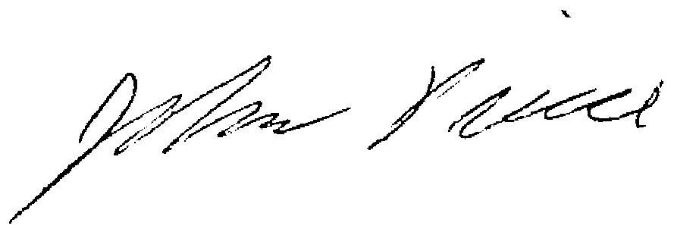

J. Pierce, Chair, Academic Integrity Subcommittee
Vice-Provost (Teaching and Learning)

