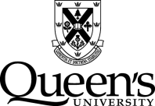

Academic Integrity Subcommittee

Annual Report 2019/20

For Senate Committee on Academic Development (SCAD) and Senate Committee on Academic Procedures (SCAP)

Terms of Reference
Reporting to SCAD on matters of policy and to SCAP on matters of practice and procedure related to academic integrity, the Subcommittee has the following terms of reference:

- To advise on initiatives, programs, and activities designed to make academic integrity an integral part of Queen's University;
- To review and make recommendations to SCAD on matters of policy relating to academic integrity;
- To review and make recommendations to SCAP on matters of practice and process relating to academic integrity;
- To collect, retain, review, and prepare an annual report for the review of SCAP on central, university-wide academic integrity statistics/data;
- To review and advise on the development of educational and awareness programs and resources for Faculties, instructors, and students;
- To review matters of policy and procedure related to academic integrity arising from cases and activities in Faculties, Schools, and academic units;
- To deal with other matters related to academic integrity as referred to it (by Senate, SCAD or SCAP);
- To act as a point of reference relating to matters arising from the interpretation of policies and practices;
- To share information with and direct the Academic Integrity Roundtable on matters relating to Academic Integrity policy and practice, education and training.

The Academic Integrity Subcommittee is not empowered to render decisions on ongoing cases of Academic Integrity

Membership
The Academic Integrity Subcommittee membership included:
Membership | Affiliation | Status
Ryan Adlem | (SGPS) Student-at-Large | Voting Member
Jeremy Ambraska | SGPS President | Official Observer
David Bath | AMS – Commissioner External Advocacy | Official Observer
Bronwyn Bjorkman | Faculty - LLCU | Voting Member
Lavonne Hood | University Ombudsman | Official Observer
Lon Knox | University Secretary & Corporate Counsel | Official Observer
Cheryl Pulling | Faculty – School of Nursing | Voting Member
John Pierce | Vice-Provost (Teaching and Learning) | Voting Member and Chair
Kate Rowbotham | Faculty - Smith School of Business | Voting Member
Vacant | AMS Student-at-Large | Voting Member
Jenn Stephenson | Associate Dean, Arts and Science | Observer

Activities
The Academic Integrity Subcommittee met four times during the 2019-20 academic year. The Subcommittee discussed and advised on the following items:

- Technology to Track and Streamline Academic Integrity Offences and Procedures
Over the past year the number and complexity of departures from academic integrity have increased substantial. It is evident that the University needs to utilize technology to track and streamline academic integrity offences and procedures. The goal is to create a pan-university portal that would be monitored by a central academic integrity officer. Leveraging technology will create a central record repository and at the same time assist instructors by redirecting them to their respective faculty/school procedures. The portal will make available to instructors, templates that will reduce their workload and prevent errors. The templates to be uploaded include: Notice of Investigation; Notice of Findings; Notice of Dismissal; and, draft emails for instructors. Ideally, the implementation of a central portal will also streamline annual Senate reporting on the number and type of academic integrity cases in each faculty/school.

Recently, both commercial and in-house programs were explored with a keen eye on protection of privacy features. Currently, the Division of Student Affairs (DSA) employs a software package named ADVOCATE to manage non-academic student conduct. After several conversations with the senior DSA leadership and a corporate client manager, plus participating in two demos, the Vice-Provost (Teaching and Learning) portfolio will be moving forward in the fall semester with a pilot project using the ADVOCATE platform. Results of the pilot will determine if the software could be implemented across the University.

- Integrity Matters Module
The University of Waterloo has successful converted and shared the content of their Integrity Matters app into a D2L tutorial. The Centre for Teaching and Learning has customized the content for Queen’s and uploaded the materials to onQ. The tutorial can be used as an education tool to improve student knowledge and understanding about academic integrity. It can also be used as a remedial instrument in cases where there is a finding of departure from academic integrity. Depending on the extend and severity of the departure, a student may be assigned specific module(s) to complete as a sanction.

- Unauthorized Use of Intellectual Property
As described in the 2018-2019 Academic Integrity Annual Reported, both SCAD and SCAP recommended that the Senate Policy on Academic Integrity Procedures – Requirements of Faculties & Schools be amended to include Unauthorized use of Intellectual Property as an official offence. This amendment fills a gap in the University’s procedures and clearly states that infringements on intellectual property are a departure from academic integrity. The Senate approved the amendment on October 29, 2019.

- Additional Offences versus Fundamental Values
Throughout the 2019-2020 academic year, the Academic Integrity Subcommittee discussed the appropriateness of adding additional offences to the Senate Policy or replacing the current six offences (plagiarism, use of unauthorized materials, facilitation, forgery, falsification, and intellectual properties) with the core fundamental values (honesty, trust, fairness, respect, responsibility and courage). At this time, the Subcommittee has agreed to retain the current offences and add a generalized offence of “departure from the values of academic integrity” for complex cases that cannot be pigeonholed into a particular category. The Subcommittee will define and provide examples for the new offence before seeking SCAD and SCAP approval.

Future Actions
The Academic Integrity Subcommittee’s future work will focus on:
- Review of the Senate Policy – Requirements for Faculties and Schools Offence: In order to create more consistency across all facilities and schools, a review of the Academic Integrity Procedures – Requirements of Faculties & Schools will continue into the 2020-2021 academic year. In addition to identifying sections that do not align with the standard process for instructors involved in academic integrity, the review will consider the current option of de novo hearings, levels of offences and the unsustainability of how Queen’s employs academic regulations that address academic integrity.
- Remote Proctoring Guidelines: With the sudden shift to online learning due to COVID-19, new challenges have arisen regarding academic integrity and online live-proctoring exams. As the University works through the intricacies of proctoring online exams, the Subcommittee will lend its expertise as guidelines are developed.
- Guidelines for Students: To assist students, a document is being created that will address what students should expect at an appeal hearing and how to write an appeal letter.
- Facilitation Offence
The present description of the Facilitation offence is:

Deliberately enabling another’s breach of academic integrity. Examples: Knowingly allowing one’s essay or assignment to be copied by someone else for the purpose of plagiarism

Concern has been raised about the word “Knowingly” currently used in the description of the Facilitation Offence. A recent case involved a situation where a student shared an assignment with a friend but was unaware that their work was subsequently being plagiarized by that friend. In the future, the Subcommittee will be considering to what extend is a student responsible for protecting their work from potential misuse.

Academic Integrity Roundtable

The Academic Integrity Roundtable is an information-sharing and advisory forum for those who are intimately involved in the implementation and operation of the university’s academic integrity systems. The Academic Integrity Roundtable reports directly to the joint SCAD/SCAP Academic Integrity Subcommittee. The Subcommittee is required to share information with the Roundtable on matters relating to academic integrity policy and practice, education and training. The Roundtable met twice during the 2019-20 academic year and provided input on: revisions to the annual case summary report; academic integrity offences; templates for instructor use; wording of Facilitation offence; and, alignment of faculty/schools procedures and practices with the Senate Policy on Academic Integrity – Requirements of Faculties and Schools.

Respectfully submitted,
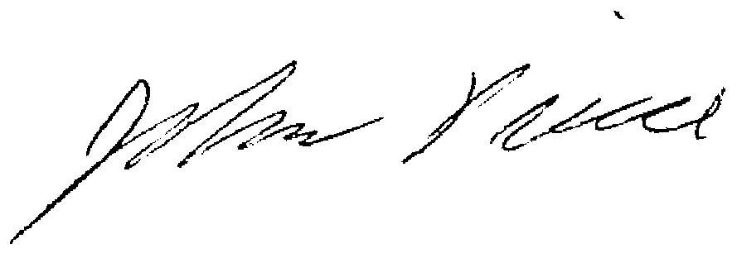

J. Pierce, Chair, Academic Integrity Subcommittee
Vice-Provost (Teaching and Learning)

