DEPARTMENT OF
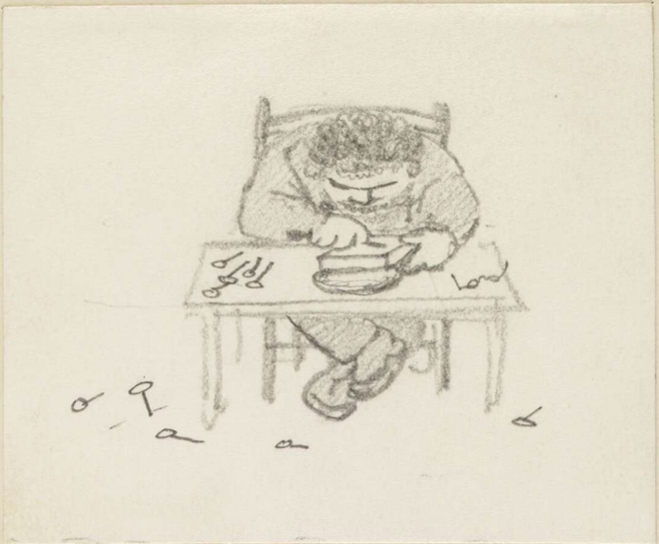
ART HISTORY & ART CONSERVATION

ARTH 865
Global Arts and Crafts

INSTRUCTOR: Antonia Behan

Edward Burne-Jones, William Morris making a wood block, c. 1886
_________________________________________________________________________________________

COURSE DESCRIPTION:
This research-led course will examine the legacies of William Morris and the Arts and Crafts Movement around the world. We will look at a variety of craft revival movements and a range of media and crafts, but we will focus on figures who most directly responded to Morris himself. Why were so many people around the world inspired by Morris? What did they embrace and what did they critique? How did the principles of Arts and Crafts change over time? We will look at cases from Japan, America, Ireland, Russia, Indigenous North America, South Asia, Germany, Hungary, Canada, and Aotearoa New Zealand. We will begin by grounding ourselves in Morris’s own work and writings, and then consider how his ideas were taken up in different places and in the contexts of modernism, imperialism, settler colonialism, nationalism, and gender. It will be structured around detailed readings and discussion of primary texts and the examination of objects, interiors, and architecture. Our primary methodological question will be that of the relationship between texts and objects, and, more specifically, the translation, appropriation, and reinterpretation of Arts and Crafts ideals in global and transnational contexts. We will think through these questions as we also consider how Arts and Crafts can be translated into a digital humanities project.

