DEPARTMENT OF ART HISTORY & ART CONSERVATION
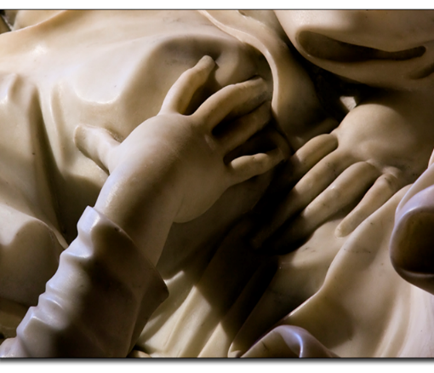
ARTH253: BAROQUE ART
_________________________________________________________________________________

CALENDAR DESCRIPTION:

The Baroque era (c.1580 – c.1800) produced the first truly global arts style. Its greatest artists, from the controversial Caravaggio to the consummate courtier Élisabeth Vigée Le Brun, focused more intensely on the viewer than ever before. Baroque art was the product of a world in crisis very like our own, with wars, plagues, power struggles, human trafficking, and colonialism. This course will explore Baroque art in Europe, Latin America, Africa and Asia.

COURSE DESCRIPTION:

This course considers the art and architecture of Europe and beyond from c. 1580 to c. 1800, the period usually defined as Baroque & Rococo. An era of astonishing artistic activity, it was marked by lavish patronage by popes, cardinals, and princes, centring on the cosmopolitan capitals of Rome, Paris, and Amsterdam, with prodigious activity in city and country from Lisbon to St Petersburg, Lima to Buenos Aires. This period was characterized by fundamental changes in society, including the rebirth of the Catholic Church as we know it today, new and revolutionary scientific discoveries, a new global awareness, warfare and plague, and the growth of political absolutism. Explores how these developments informed the style, iconography, and patronage of art and architecture, and highlights artists such as Caravaggio, Bernini, Borromini, Rubens, Rembrandt, Velázquez, and De La Tour. Taking the position that international versions of Baroque & Rococo are dialects of a global language, it explores the uniqueness of global variants of Baroque art and architecture and how they relate to their social context. Topics considered include the clash between Classical and Gothic traditions, the rise of the academies, landscape painting, still life, genre painting, and colonialism, as well as the concept of the Baroque unity of the arts, or “bel composto.” This course will not only consider painting, sculpture, and architecture, but also décor and “decorative arts,” ephemera, and gardens.

COURSE REQUIREMENTS:

A detailed list of readings and requirements will be available during the first class. The assignments will consist of mini essays and a term paper.

