DEPARTMENT OF ART HISTORY & ART CONSERVATION
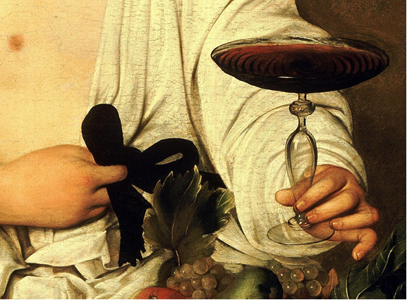
ARTH451: CARAVAGGIO & ARTEMISIA
_________________________________________________________________________________

CALENDAR DESCRIPTION:

Michelangelo Merisi da Caravaggio (1573–1610) and Artemisia Gentileschi (1593–1654) are two of the best-known and most controversial artists of all time. This course explores how their art viscerally reflects the violence, passion, and religious struggles of their day and may even be autobiographical. Their questioning of sexual and gender norms predates more contemporary artists such as Andy Warhol and Tracey Emin.

COURSE DESCRIPTION:

This course explores the impact of one of the best known artists of all time, Michelangelo Merisi da Caravaggio (1573-1610), and his contemporaries in Baroque Italy. A pop icon today who has inspired an entire industry of scholarship, novels, and a feature film, this tormented, sensual, yet deeply pious artist is the only Italian Baroque painter to remain a household name. We will explore Caravaggio’s intense naturalism and populist piety and the controversies caused by both, his relationship with Catholic devotions and religious orders, his sense of drama and supernatural light, and the role of his personality in works of art. We will consider how Baroque Italians interpreted religious paintings; how they viewed the saints and sinners depicted in them; and the dynamics of art commissions. This course will also look at the most prominent woman painter of the Baroque, an equally controversial figure named Artemisia Gentileschi, who has occupied a comparable place in the popular imagination. An artist who was deeply influenced by Caravaggio but who developed her own unique style, Artemisia has been the subject of an impressive amount of recent scholarship, a novel, a Broadway play, and a feature film. Both Caravaggio and Artemisia combine the sensual and the sacred and have larger-than-life biographies. One of the goals of this course is to look at the ways in which these artists’ personalities have been projected onto their work by scholars, essayists, novelists, and filmmakers.

COURSE REQUIREMENTS:

A detailed list of readings and requirements will be available during the first class. This course will be a seminar, with discussions. The assignments will include oral presentations, class participation, and a term paper.

