ARTH 203 Art and Popular Culture
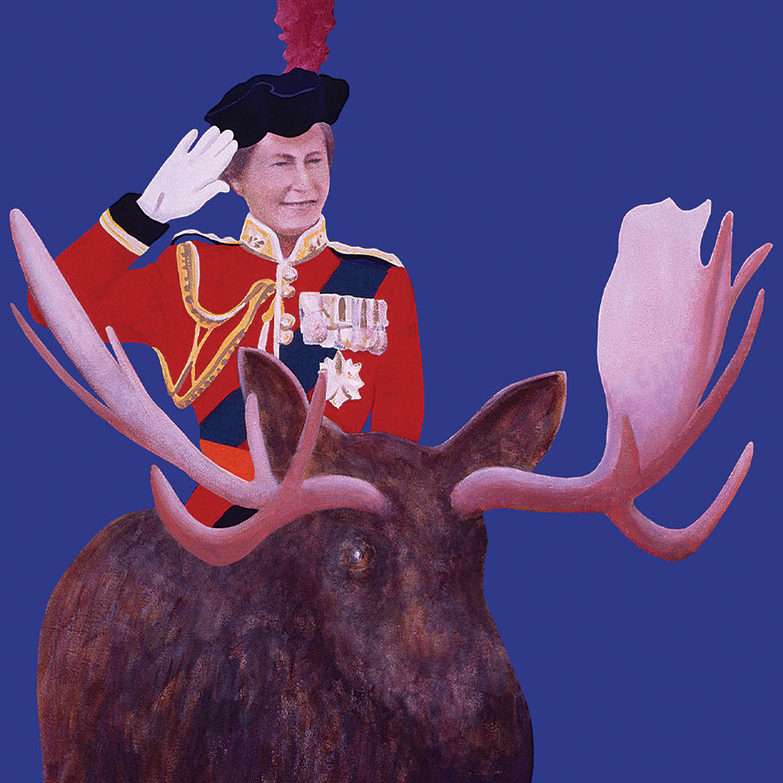

What does The Matrix Trilogy have to do with critical theory? What does Harry Potter tell us about our fascination with the Middle Ages? What is “camp” and what does it have to do with queer culture and representation? As art is freed from the confines of the gallery where it is conventionally located in Western art history, it potentially becomes a “popular”, even democratising medium accessible to anyone with access to television, radio, urban space, and the internet. This course explores the proliferation of accessible art from cinema to popular music, “pop” art, literature, and theatre. Working across media, we will consider the films of Derek Jarman, Ridley Scott, Quentin Tarrantino and others; the response of “popular culture” to human crises such as AIDS and climate change; LGBTQIA+ art and politics; the visual and sonic landscapes of hip hop; the art, video and music of Punk and Post Punk; key ideas about faith and spirituality; and of course popular art in Canada. ARTH 203 shows that social change was often enacted by or through popular art, but it also insists that the art of popular culture was learned, intelligent, and historically aware.

