DEPARTMENT OF ART HISTORY & ART CONSERVATION

ARTH 120/6.0: ART IN THE WEST FROM ANTIQUITY TO MODERNITY
Fall Term 2023/Winter Term 2024
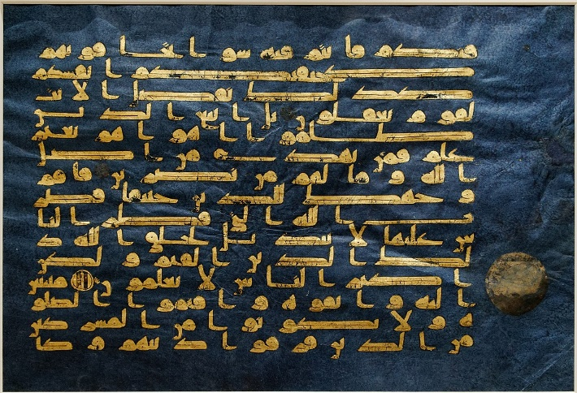
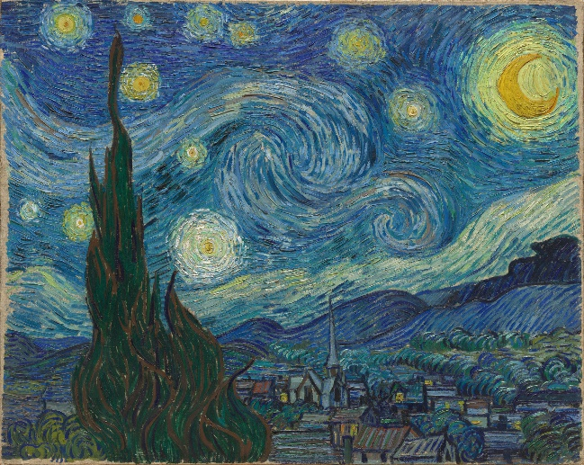

CALENDAR DESCRIPTION:
A survey of famous and lesser-known works of painting, sculpture, architecture, and other art forms from Antiquity, the Middle Ages, the Renaissance, the Baroque, and the Modern Age. Themes include politics, religion, mythology, gender roles, techniques, conservation and intersections with non-western cultures.
Prerequisites: None.
Exclusion: When both ARTH 116 and ARTH 117 are taken they exclude ARTH 120.

COURSE DESCRIPTION:
This course forms the foundation for the art history major and minor but is open to all students interested in learning how to look and think critically about visual images. Discover how art and architecture have contributed to, reflected, and shaped issues and ideals in western society from prehistory to the present.

LEARNING OUTCOMES:
By the end of this course, students will be able to:

1. state basic facts about art from different periods and cultures of the western world and to define basic art historical terminology.
2. recognize and identify qualities of art associated with different styles and cultures of
the western world.
3. demonstrate an understanding of artistic development across time from the prehistoric
to the current era.
4. compare and contrast different works of art from various times and cultures in order to draw meaningful connections.
5. implement visual analysis in order to understand and interpret meaning and intention embodied in works of art
6. independently research, analyse, and contextualize works of art not presented in lecture or Janson’s History of Art

MARKING:

Fall Term:
What’s Your Take? 20%
Test #1 10%
Test #2 10%
Attendance/Participation in Tutorials 10%

Winter Term:
Amend the Story 20%
Test #3 10%
Test #4 10%
Attendance/Participation in Tutorials 10%

