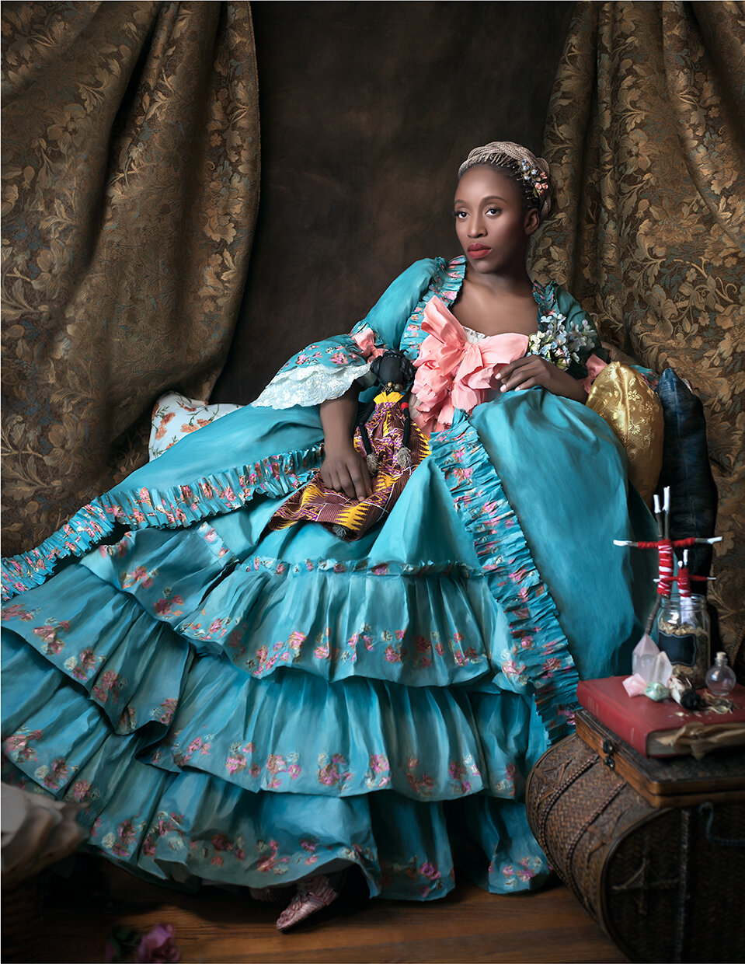

ARTH 225/3.0:
Fashion and Art:
From the Renaissance to the Present
Fall 2023

Fabiola Jean-Louis, Marie Antoinette Is Dead, 2017.

COURSE DESCRIPTION
Is fashion art? What is the role of dress in the fine arts? How can visual culture be used to help us grasp the material world of the past? This course considers these questions through an exploration of the relationship between fashion and art from the Renaissance to the present. By analysing objects from visual and material culture, we will investigate artists’ use of dress to construct narratives or convey the qualities of a sitter, crossovers between art and fashion (artists designing dress and dressmakers designing art), and the impact of social and cultural shifts on dress and its representation in art (with a particular emphasis on issues of gender, status, and cross-cultural exchange). We will further consider fashion itself as a form of artistry, and how acknowledging dress offers access to makers and narratives locked out of more traditional forms of representation.

Prerequisites: Level 2 or above or permission of the Department.
Recommended: ARTH 120/6.0.

