DEPARTMENT OF ART
ART HISTORY & ART CONSERVATION

ARTH 841: Studies in Italian Renaissance Art

Moving Images: Sculptures, Ritual, and Living Traditions

Fall 2023

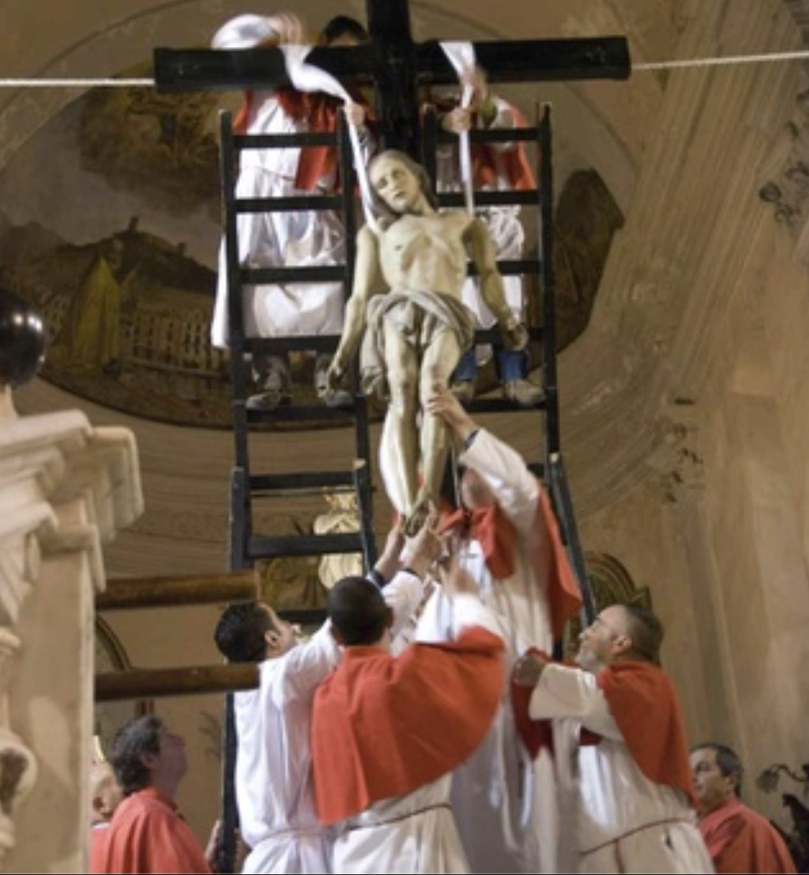

_________________________________________________________________________________

COURSE DESCRIPTION:
People performed rituals with sculptures in the Renaissance and, in many parts of Italy, continue to practice the same kinds of devotional acts today in a living cultural tradition that spans over half a millennium. We will explore the forms of ritualized prayer, processions, and ceremonial performances that structured how people interacted with sculptures, examining surviving Renaissance sculptures and textual and visual sources from the period. We will also watch videos of these rituals being performed in the 20th and 21st centuries, sometimes using early modern sculptures, and explore how we can use such modern rituals as evidence of a vital cultural heritage that brought and brings statues to fleshy life.
As a central part of the course, students will individually and collectively research, write, and curate a digital exhibition, which will be published at the end of the course.

