DEPARTMENT OF ART
ART HISTORY & ART CONSERVATION

ARTH215/3.0
Renaissance Art and Architecture after 1500
Winter 2021
INSTRUCTOR: Professor Una D'Elia
EMAIL: deliau@queensu.ca
OFFICE HOURS: TBA
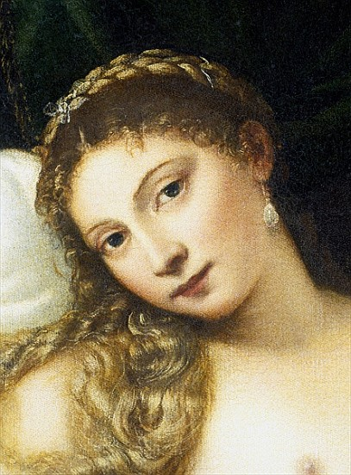

CALENDAR DESCRIPTION: A study of Renaissance art and architecture after 1500 within the context of the social, political and economic history of Western Europe. Key monuments, themes and concepts will be stressed.

Prerequisites: Level 2 or above or permission of the Department.

COURSE DESCRIPTION:
This course examines both some of the most famous works of such artists as Leonardo da Vinci, Raphael, Michelangelo, and Albrecht Dürer, and lesser-known oddities of Renaissance painting, sculpture, and architecture in Italy and the North from ca. 1500 to ca. 1600. In this period, the conventions that governed Western art until the nineteenth century were invented in a creative process that was anything but conventional. Renaissance art was not divorced from but a part of everyday life. Art was used to aid devotion, as decoration, political propaganda, a reminder of a dead loved one, a diplomatic gift, erotica, an almost magical totem, a collectable, or even a form of punishment. The course will address the fundamental problem of how the forms of Renaissance art related to the diverse functions that they served. Issues to be discussed include style, problems in defining “realism,” the revival of Antiquity, the status of the artist, patronage, gender, sexuality, changing notions of decorum, concepts of beauty, and the relationships among art, science, religion, literature, philosophy, and politics.

Please note: The mode of delivery (on campus or remote) has not yet been confirmed. A syllabus will be available by the beginning of the winter term with detailed information on the course and its requirements.

