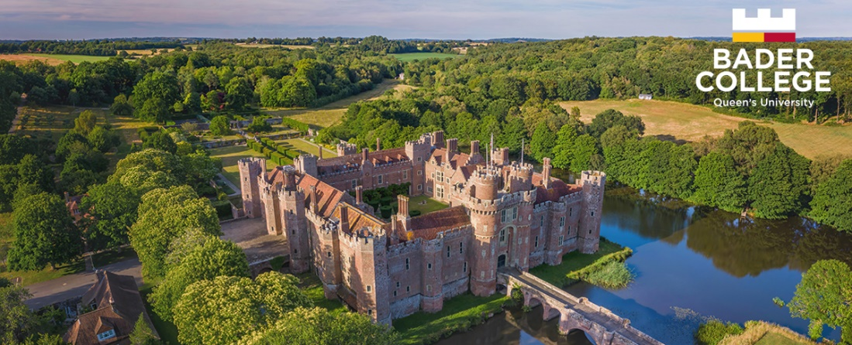

Director of Estates

Overview

Bader College, located at historic Herstmonceux Castle, East Sussex, is the overseas campus of Queen’s University, Canada. The campus occupies a 600-acre estate, including a range of academic, residential, and recreational facilities. Our dedicated faculty and staff provide exceptional academic programming for undergraduate and postgraduate students from Canada and around the world. We also serve as a venue for international conferences and meetings. Our wholly owned trading subsidiary, Herstmonceux Castle Enterprises Limited (HCE), is responsible for running the gardens and grounds, corporate events, and other functions.

Herstmonceux Castle and its constituent buildings are designated scheduled monuments and listed buildings respectively. The Castle is Grade I, the Observatory Science Centre Grade II*, and the woodland areas surrounding the buildings Grade II.

The Director of Estates is a newly created role within the senior management team which will oversee the implementation of our ambitious strategic plan for our physical environment. The successful candidate will be responsible for two departments consisting of Buildings and Facilities and Gardens and Grounds. The Director will also be responsible for overseeing all capital projects planned for the estate and the identification and management of new projects to develop the Estates.
Bader College is committed to employment equity, inclusion and diversity and supports fair treatment and opportunity for all. No job applicant, employee or worker is discriminated against either directly or indirectly on the grounds of age, disability, gender reassignment, marriage and civil partnership, pregnancy or maternity, race, religion or belief, sex or sexual orientation.

Working hours: The role is full-time and normal working hours will be 37.5 hours per week over 5 days, with additional flexibility as required for the role.

Salary: £competitive.

Job Description

Main purposes of job | Overall strategic and operational management of the estate, physical resources and facilities, including Grade 1 and Grade II Listed buildings and grounds of approximately 600 acres.  Control of all capital projects currently in progress and those planned for the future ensuring value for money and quality of work.  Development, design and implementation of plans for the future in alignment with our strategic plan.  Line management of the Head of Buildings and Facilities and the Head of Estate, Gardens and Grounds.
Main duties | - In conjunction with the Senior Management Team (SMT) and reporting to the CEO (VPED):  - create and implement comprehensive and integrated, long-term strategic plans which align with the College’s strategic plan to maximise the full potential of the Estates to provide a safe, inclusive and welcoming space for our students, staff and visitors.  - take a strategic approach to the management of the Estate and buildings to protect and enhance the working environment for the short- and long-term.  - produce and implement a plan to enable us to become carbon neutral by 2030 and consider and create plans for nature recovery and increasing biodiversity across the Estate.  - oversee implementation of all planned and future capital projects relating to the physical resources across the Estates.  - contribute to the business continuity plan for the estate in collaboration with other parts of the organisation.  - provide effective line management to the Head of Estate, Gardens and Grounds and the Head of Buildings and Facilities.  - ensure that the Directorate operates financial controls to ensure that projects are implemented on time and to budget.  - in conjunction with the Health and Safety Officer, ensure that identified risks are mitigated and remedial works are planned and budgeted.  - develop, implement, and maintain robust and efficient systems and processes including risk management for own area of the business.
Additional duties | - Other reasonable duties as required, including acting as the Duty Manager on call on a rota basis.
Key results/objectives | - Creation and delivery of an implementation plan to realise our vision for the future of the Estates in accordance with our strategic plan.  - Implementation of the planned and future capital projects relating to the physical environment.
Responsible for staff/equipment | Head of Estate, Gardens and Grounds and Head of Buildings and Facilities
Reporting to | Chief Executive (Vice-Provost and Executive Director)

Person Specification

Criteria | Essential
Qualifications | Qualified surveyor (RICS or similar qualification).
Skills/competencies | - Ability to manage complex and listed properties, land, staff and budgets.  - Strategic and organisational skills including planning and budgeting large and complex projects.  - Excellent written and oral communication skills.  - Strong ability to influence and negotiate.
Knowledge and experience | - Extensive experience of managing complex estates, including experience of managing listed buildings and land projects as well as buildings and facilities maintenance.  - Experience of leading and managing a diverse, motivated, and dedicated team to deliver results.  - Experience of converting strategic plans into tangible outcomes.
Personal qualities | - Willingness to take responsibility and ownership.  - Ability to manage a high volume of work in a calm and efficient manner.  - Ability to build effective working relationships.  - Attention to detail and accuracy.  - Ability to analyse issues and solve problems.  - Engagement in continuing own professional development and that of direct reports.
Other | - Permission to live and work in the UK  - Successful completion of an enhanced DBS check
JD written/reviewed | Created July 2023

