Download course files through Manage Files in onQ (Brightspace/D2L)
The Manage Files tool is a file management system for your course. You can use this tool to organize, upload/download individual files associated with your course offering.

Download individual files through Manage Files
- Select the Administration link in the navbar, then Course Admin
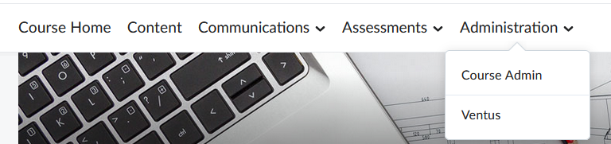
- Under Site Resources, click Manage Files
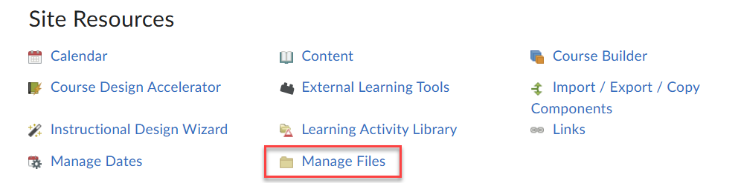
- Select files you wish to download, then click the download icon at the top of the file list
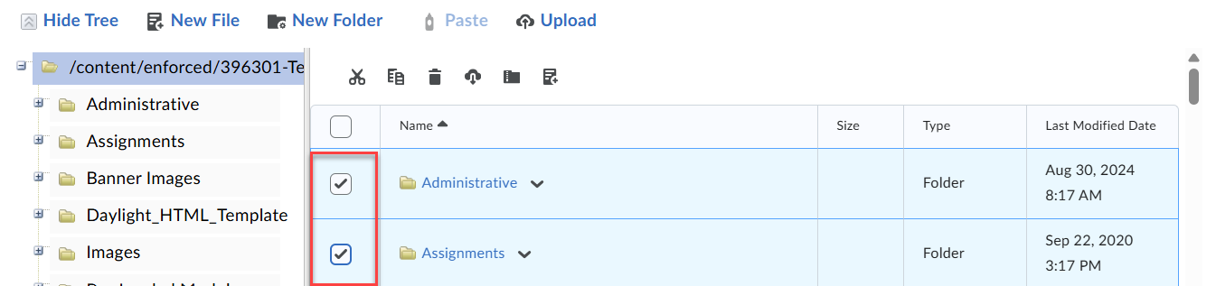
- The files will be packaged into a .zip file for download

Note: If you have large video files that you’re concerned about storing, they can be uploaded directly to Panopto (Queen’s streaming service).

How to upload video files to Panopto:
- Log in to Panopto through Queen’s University
- Select the My Folder link
- Click the Create button, then Upload Media
- Drag and drop your video file or browser your computer to select it
- Wait for the upload and processing to complete

