How to export a course in onQ (Brightspace/D2L):
Instructors can export all or part of an onQ course as a .zip file. This creates a backup copy of the course, which can be useful when courses are archived.
Exporting a course allows instructors to create a copy of the course design and content that can later be imported into another course. The exported course does not include any student data such grades or submission folder files.
NOTE: The .zip package can only be imported into other onQ (Brightspace/D2L) courses.

To export your onQ course:
- Select the Administration link in the navbar, then Course Admin
- Locate Import/Export Copy Components link under Site Resources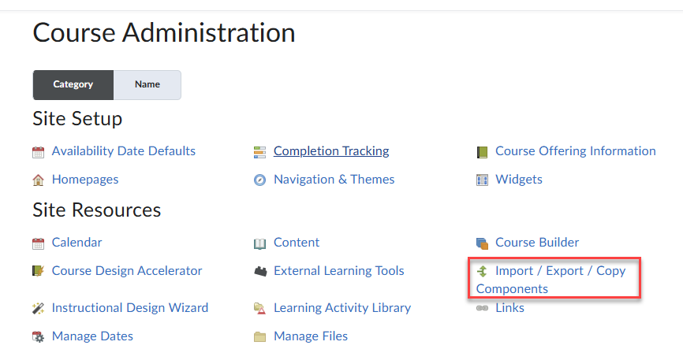
- Choose Export as Brightspace Package and select Start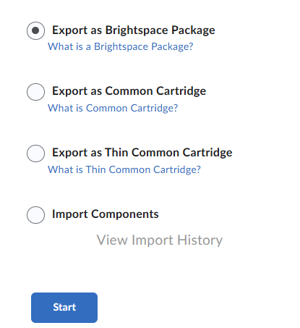
- Select All Components to export everything, or select specific items, then click Continue
- Ensure the checkbox to include course files in the export package is checked, then click Export
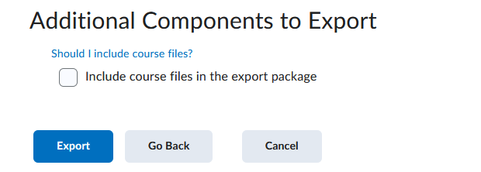
- You will see the message Your export has been started. You will receive a notification in the Update Alerts when it has completed. Click Done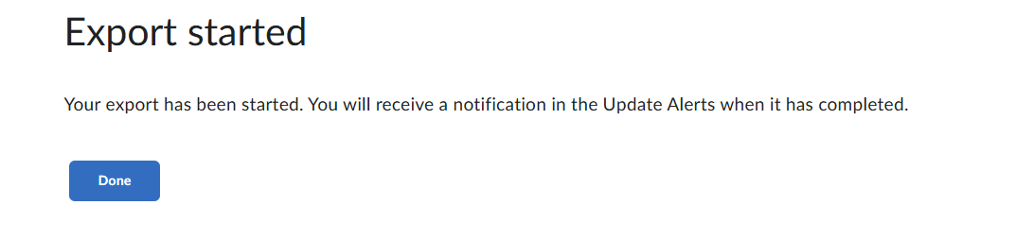
- A notification will display in the Mini-bar when the export is complete
- Select Export finished, then Click here to download the export Zip package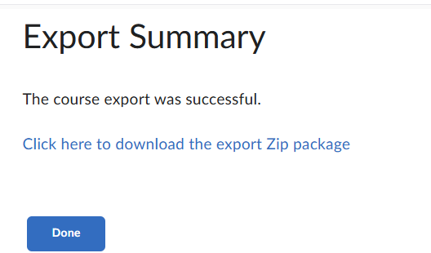
- Click Done
- The file will be saved to the downloads folder on your computer

