Tips for Zoom Breakout Rooms

General Tips:
- In your Zoom settings, enable the authentication option to only allow Queen’s users to join, and to allow pre-assigned breakrooms to run smoothly.
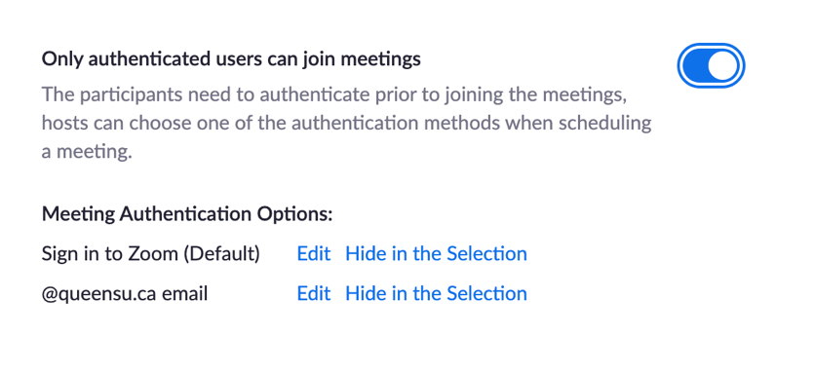
When you’re scheduling a meeting, enable the authentication option and select “@queensu.ca email”
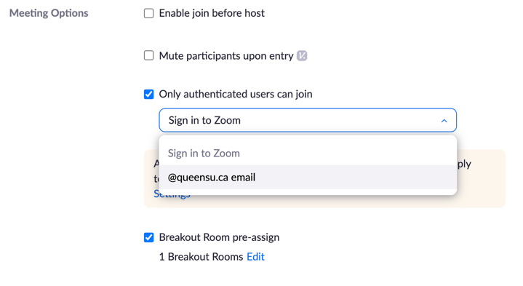

- Both students AND instructors must be using their NetID account (through the Single Sign On) when signing in to Zoom to join the scheduled meeting. Entering your login information directly in the Sign in area will not work unless you log in through the SSO. If you’ve been previously logged in, Zoom will automatically let you into the meeting without logging through SSO. In the Zoom app, you must click “Sign in with SSO”, then enter “queensu” in the domain, and then sign into the NetID portal. Through the web, you can go straight to queensu.zoom.us to login.
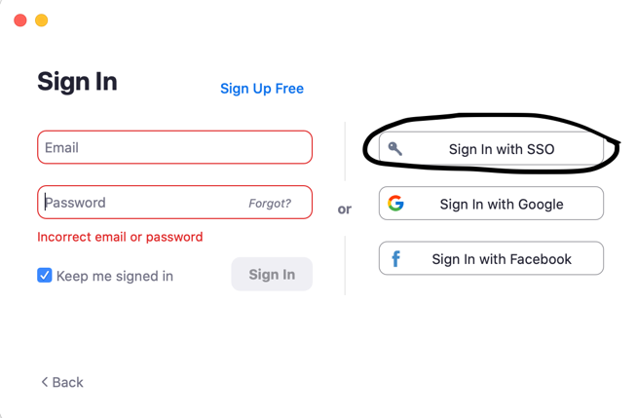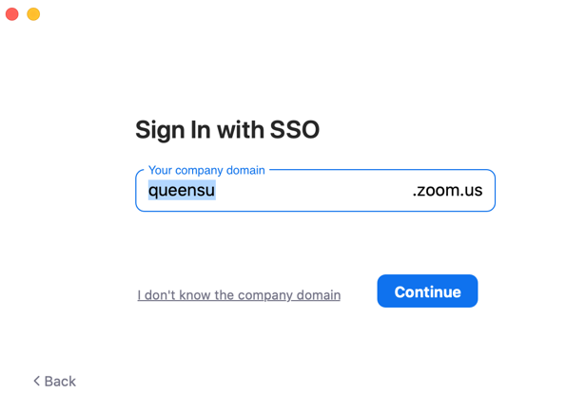

Pre-assigned Breakout Rooms

- All participants MUST use the Zoom app for the pre-assigned to breakout rooms to work. They cannot enter through the Zoom web page. They may click on the zoom link, but they must choose the option to launch the Zoom app when the prompt comes up.
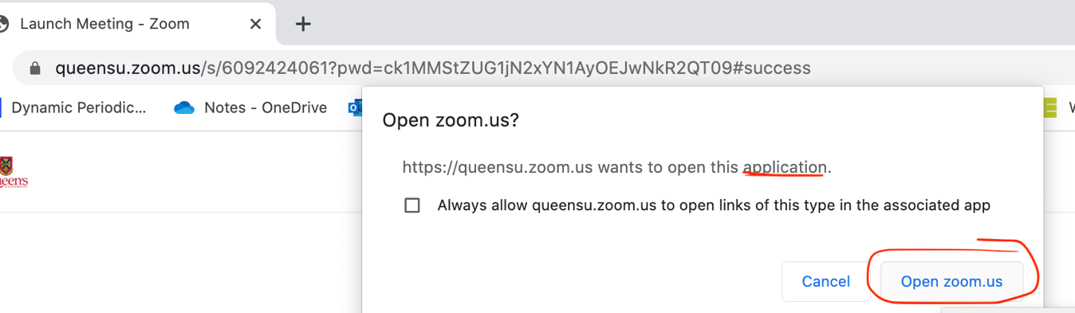

** The easiest way is to download the app, sign in through SSO, and enter the meeting ID and password directly to make sure that the app is being used.

- When creating pre-assigned breakout rooms with instructor emails, enter their NetID emails, not their first-name.last-name emails. That way, when instructors log into Zoom meetings with their NetID emails, they will be pre-assigned with their NetID emails. Instructors must make sure of which email they are using to login to Zoom to make sure that these emails match with the pre-assigned rooms.

- Members who join AFTER the breakout rooms have been opened will NOT be pre-assigned. You can either manually assign them to their respective groups, or you can recreate the pre-assigned breakout rooms. To do so, first click “Close all breakout rooms,” and then click “Recreate” > “Recover pre-assigned rooms”> “Open Breakout rooms”. (*Note: the recreate button will not appear unless you close all the breakout rooms first)
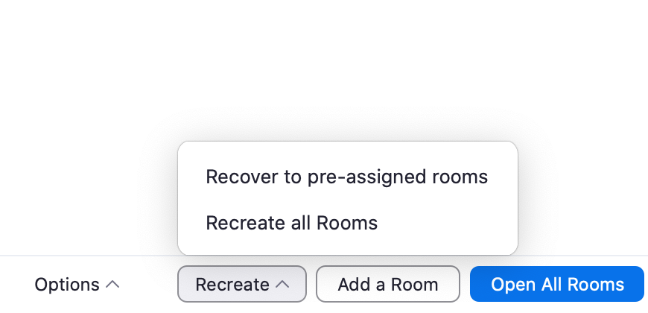

Randomly assigned breakout rooms:
- If participants enter after randomly assigned breakout rooms have been opened, you can either manually assign them, or you can click “Close all breakout rooms” > “Recreate all rooms” > “Open all rooms” to regenerate randomly assigned breakout rooms. (*Note: the recreate button will not appear unless you close all the breakout rooms first).

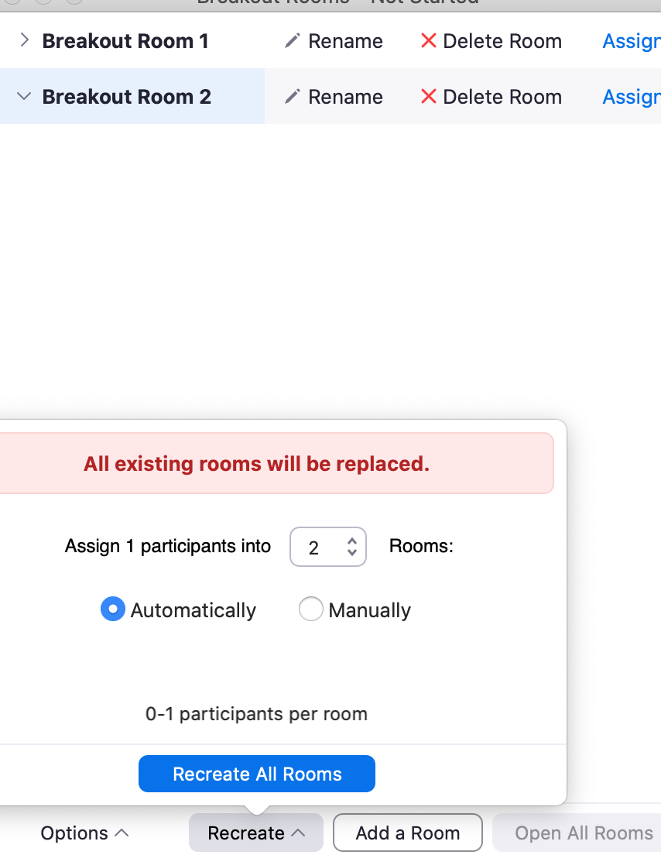

- You cannot randomly assign breakout rooms in a meeting that has been scheduled with pre-assigned breakout rooms.

