Introduction

Are you creating or expanding Experiential Learning (EL) opportunities for Queen’s students? Are you wondering how you can do this effectively and efficiently? The Experiential Learning Faculty Toolkit consists of information, resources, tools, and templates that will help you design and implement high-impact experiential learning opportunities in a time-effective manner. You can download the whole Faculty Toolkit as a PDF or find specific resources in fillable word doc format here:
www.queensu.ca/experientiallearninghub/faculty/faculty-toolkit
What is Experiential Learning?
Experiential Learning is an interdisciplinary, educational philosophy and practice that promotes academic learning outcomes, student career development and critical thinking. By participating in intentionally designed, authentic learning experiences and guided reflection, EL opportunities are created for students to further develop a wide range of knowledge, skills and values while inspiring them to make meaningful choices about their career path.
Experiential Learning at Queen’s
While Queen’s offers students a wide range of EL, both curricular and co-curricular, there is also interest from students, prospective students, faculty, program coordinators, and government in expanding EL. In 2015 an Experiential Learning Working Group (ELWG) was created by the Provost’s Advisory Committee on Teaching and Learning (PACTL) to recommend strategies to facilitate the development and growth of self-sustaining, curricular and co-curricular experiential learning opportunities for undergraduate and graduate students.
The ELWG consulted broadly with Faculties, School of Graduate Studies, instructors, student organizations, and administrative units to review current activities, strengths, and opportunities for growth, and carefully considered costs and benefits associated with the possible actions and potential impact on existing programs and services. It was found that experiential learning activities, both curricular and co-curricular, at Queen’s have value for students and the institution and a number of steps and actions, if taken, would facilitate their growth and development at Queen’s.
One of the key recommendations of the ELWG Report was to create an Experiential Learning Hub to support cross-institutional planning and delivery, and relationships with community and employer partners. The EL Hub was established in 2016 and has been developing centralized materials and tools to support the efficient and effective design and delivery of experiential learning.

The Experiential Learning Cycle
The most commonly used framework for guiding the design of experiential learning activities is Kolb’s Experiential Learning Cycle.
As outlined in the diagram below, students will have an intentionally designed, concrete experience on which they will reflect and from which they will draw conclusions and generalizations. Students will then apply this learning in future situations.
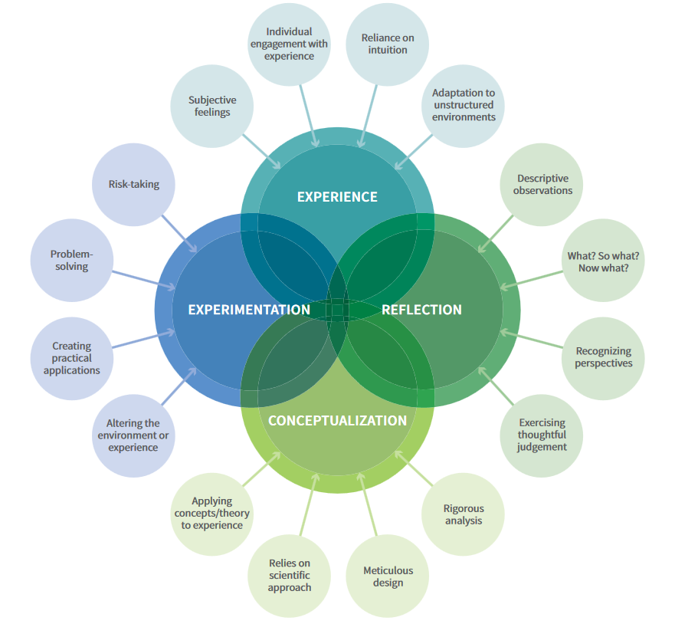

Interested in learning more about experiential learning theory and pedagogy? Check out these resources:
Resource | Source | URL
Niagara College Canada | Experiential Learning Toolkit (online) | www.eltoolkit.ca
Higher Education Quality Council of Ontario | A Practical Guide for Work-integrated Learning | www.heqco.ca/SiteCollectionDocuments/HEQCO_WIL_Guide_ENG_ACC.pdf
EL Hub Publication List | Queen’s EL Hub | https://www.queensu.ca/experientiallearninghub/faculty/publications

Core Principles of EL Course Design
- Intentional design of authentic experiences that align with course learning outcomes
- Alignment between course learning outcomes and professional skill development
- Opportunities for students to set personal learning goals in alignment with course learning outcomes
- Engagement with host organization in design of EL experience
- Instructor as facilitator
- Guided reflection
- Assessment and feedback
What’s the difference between active learning strategies and experiential learning?
Active learning strategies are those where students are actively participating in classroom activities such as discussions, labs, role-playing and group work. Active learning strategies help students construct meaning and take responsibility for their own learning. Experiential learning is different from active learning because it requires the design of an experience located within an intentional learning cycle that involves reflection, conceptualization and experimentation that leads to the achievement of learning outcomes.
What are the components to consider in EL design and delivery?
Experiential learning activities are complex to manage.
The diagrams below provide an overview of the many curriculum design and logistical planning components that should be considered and can be supported by the EL Hub or other campus resources when designing and delivering experiential learning.
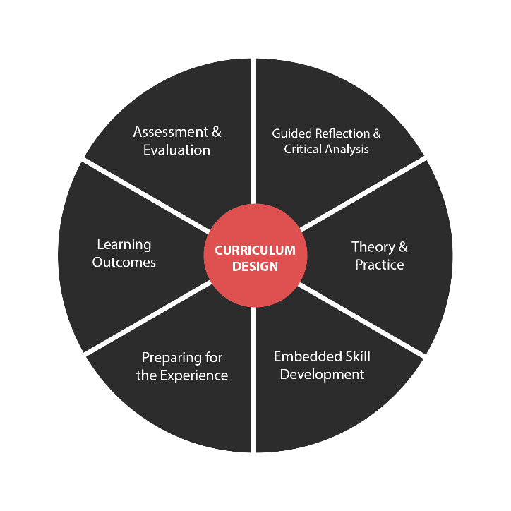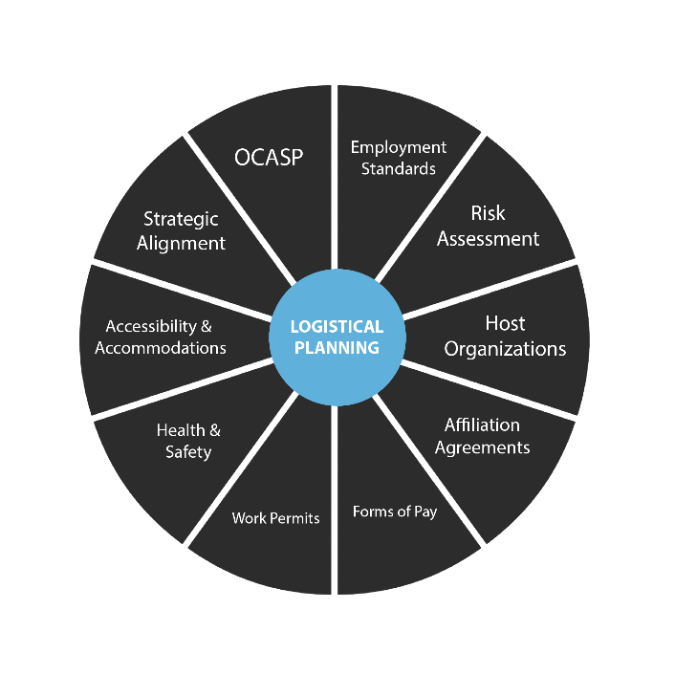

Types of Experiential Learning at Queen’s
Queen’s facilitates experiential learning opportunities in a number of dynamic and innovative ways. The ELWG categorizes types of experiential learning at Queen’s as follows:
Curricular-based mandatory work-integrated internships (continuous 12-16 month, paid) in a 5- year undergraduate degree stream with “with Professional Internship” degree title i.e. QUIP

Curricular-based mandatory practicums in clinical/institutional/workplace settings related to professional practice requirements e.g. Nursing, Occupational Therapy.

Work-integrated internship opportunities

- Mandatory, Curricular-based, course-specific, mandatory opportunities, e.g. Master of Public Health, Master of Art Conservation

- Optional, Curricular-based, course-specific, optional work-integrated opportunities, e.g. Global Development Studies Work Study, Film 395 Internship, Mitacs internships, Graduate Research Assistantships.

Experiential learning project opportunities

- Mandatory, Curricular-based, course-specific, experiential learning projects e.g. Health Studies 415: Program Design and Evaluation, Masters and Doctoral Thesis Research.

- Optional, Curricular-based, course-specific, experiential learning projects e.g. APSC 400 Technology, Engineering, and Management.

Co-curricular experiential learning opportunities, e.g. student government positions, peer programs, student club positions.

Co-curricular experiential learning work programs, e.g. SWEP and Work Study.

The EL Hub Consultation Process
If you are developing new EL or thinking about making changes to an existing EL activity, we recommend that all faculty or staff book a consultation with the EL Hub at the beginning of the planning process. Through the consultation process we will:

To request a consultation, please email us at el.hub@queensu.ca
- help you effectively use and/or modify the planning tools and EL resources in this toolkit to support the specific form of EL you are designing – saving time and helping you plot out your workplan
- connect you with examples and other instructors (as relevant) to facilitate sharing of knowledge across faculties to avoid redundancies in program development and administration
- make referrals to risk management experts on campus

Stage and Steps | EL Hub Tools and Resources  (link to Word docs)
Initial Consultation  During the consultation we will:  - review program/course goals and learning objects  - use logistical and curriculum planning charts to design an Experiential Learning opportunity that aligns with learning objectives  - use our EL Hub referral form to make referrals to on-campus experts in course design, risk management, and host organization outreach  - discuss program elements the EL Hub can support through customized workshop delivery  - schedule follow-up consultations as necessary | - EL Logistical Planning Chart  - EL Curriculum Design Chart  - Host Outreach Tips  - EL Hub Referral Form
Faculty Approval Process  As you work on your course/program design and submit proposals through your faculty’s approval process, you can:  - book a follow-up consultation with the EL Hub to discuss any outstanding or new issues/questions that arise  - inform the EL Hub when your program is approved and any modifications that were requested  - submit request to EL Hub for customized workshops | - EL Reflective Rubrics  - EL Learning Plan  - EL Host Outreach Assessment Procedures  - Student-Supervisor Agreements  - Sample Performance Evaluation Form
Implementation  Once your course or program beings, we suggest you:  - inform the EL Hub of when the course/program will begin  - check-in with risk managements experts to ensure all logistical and risk management plans are up to date (i.e. health and safety forms; affiliation agreements; OCASP)  - set up tracking system for host organization requirements / forms  - book a follow-up consultation with the EL Hub if you have questions about:  - host organization outreach and partnership development  - host organization needs/requirements  - logistical or pedagogical issues that may arise during the EL experience | - EL Forms and Documentation Tracking Chart  - Strategies for Guiding Student Reflection

Where to find EL Tools and Resources
All of our EL Tools and Resources are available as downloadable word documents from the Faculty section of our EL Hub website. www.queensu.ca/experientiallearninghub/faculty/faculty-toolkit
We encourage instructors to use the tools and resources as is, or to modify them to suit the needs of their courses, programs, students and partner organizations.
If you have any questions or would like to set up a consultation, contact us at el.hub@queensu.ca. We look forward to supporting you as you design and deliver future experiential learning opportunities.

https://www.eltoolkit.ca/designing-experiential-learning-opportunities/defining-el-frameworks-and-typologies
Kolb. D. A. and Fry, R. (1984). Experiential Learning: Experience as the source of learning and development. Englewood Cliffs, NJ: Prentice Hall

