The December 2024 upgrade was mostly on back-end fixes, but there are a few changes outlined below that will change the user experience in FAST.

Training Videos Menu Restructured
The training videos section has been redesigned.
Current Format: Videos are displayed as headings followed by thumbnails.
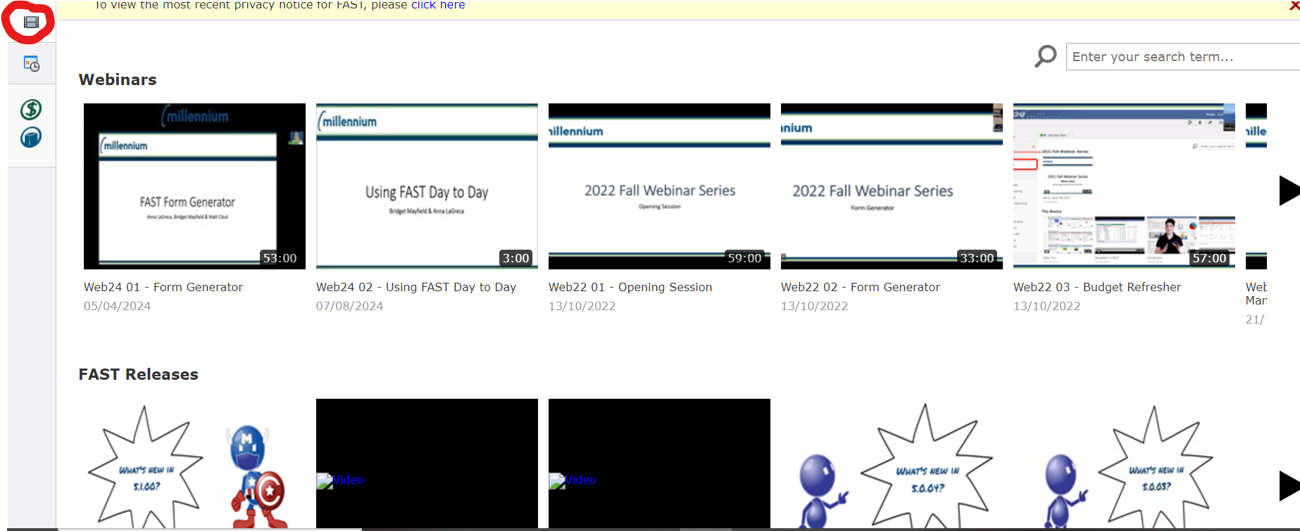
Upgraded Format: Videos will now be shown in a detailed list view for easier navigation.
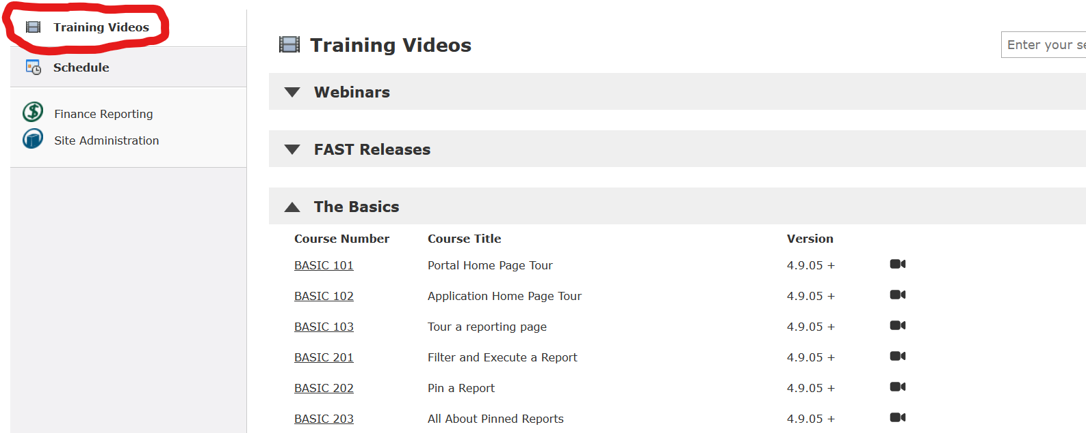

Pinned Reports Menu Changes
The pinned reports menu has been simplified from three sections to two:
Previous Sections: Favorites, Private, Group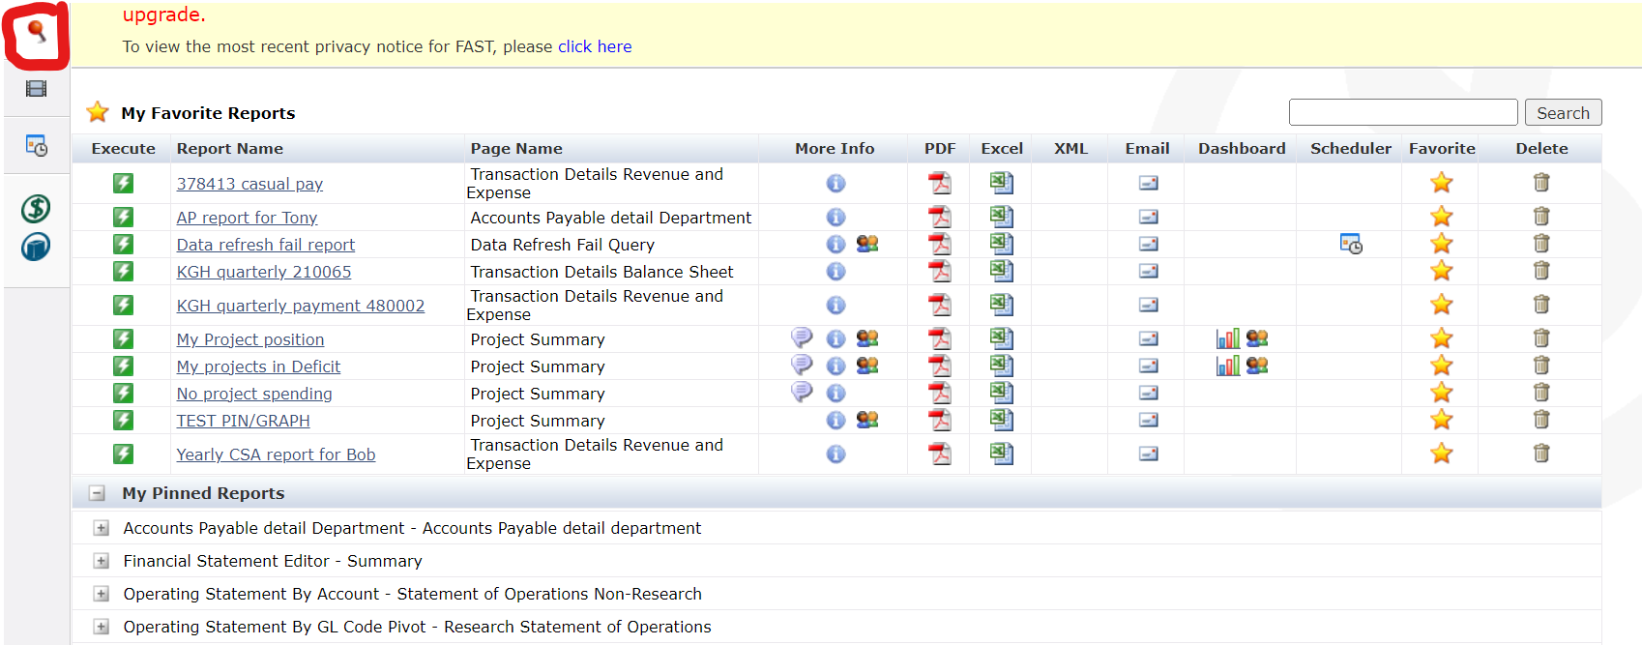
New Sections: Favorites, Pinned Reports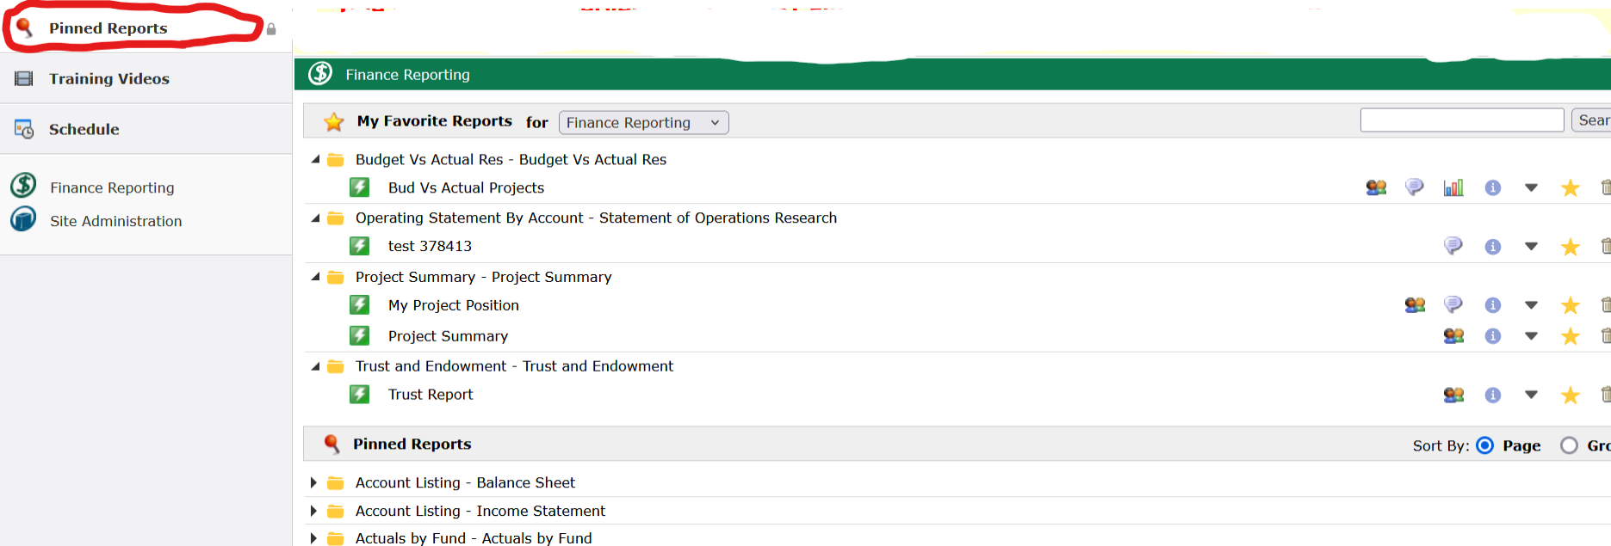

The second section can be sorted by Report or Group.
Expanded sections will remain open when you expand other sections.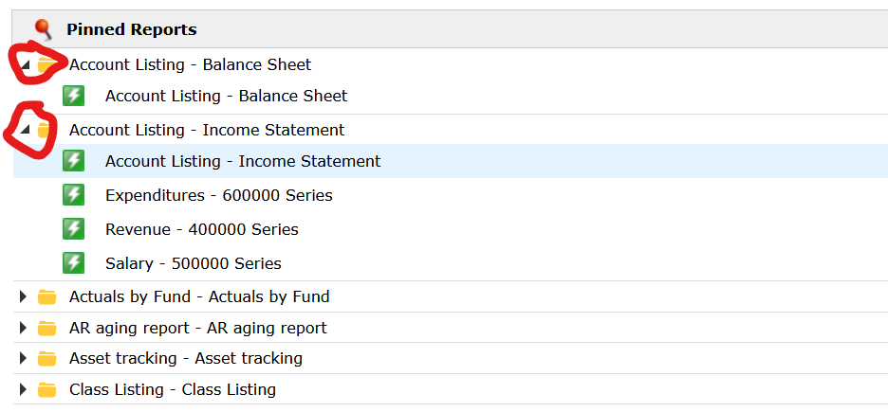
Info Icon Hover Dialog: Now includes the menu path to access the report.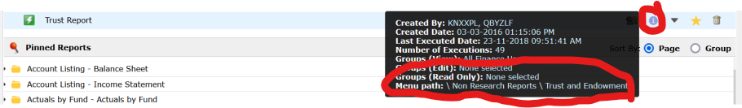
Clicking a pinned report opens it in a new browser tab.

New Shortcut: Ctrl + Enter to Run Reports from Column Filters
You can now use Ctrl + Enter to execute reports when adding column filters. This functionality was previously available only on the Filters tab and is now extended to column filters.
Selecting Ctrl+Enter after entering your filters at the screen below will execute the report.
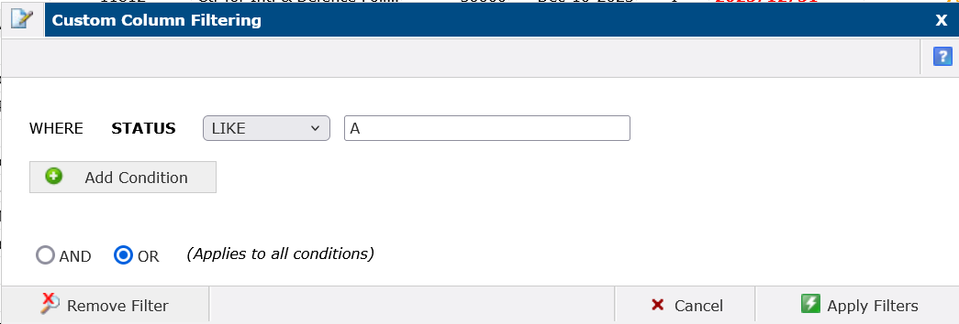
For information on column filters please click here.

New Group Function: Median
The Median function has been added to the group functions list under the Advanced Options tab, enhancing data analysis capabilities.
