Itemizing- marking Hotel expenses as personal
Choose Hotel/Motel expense type
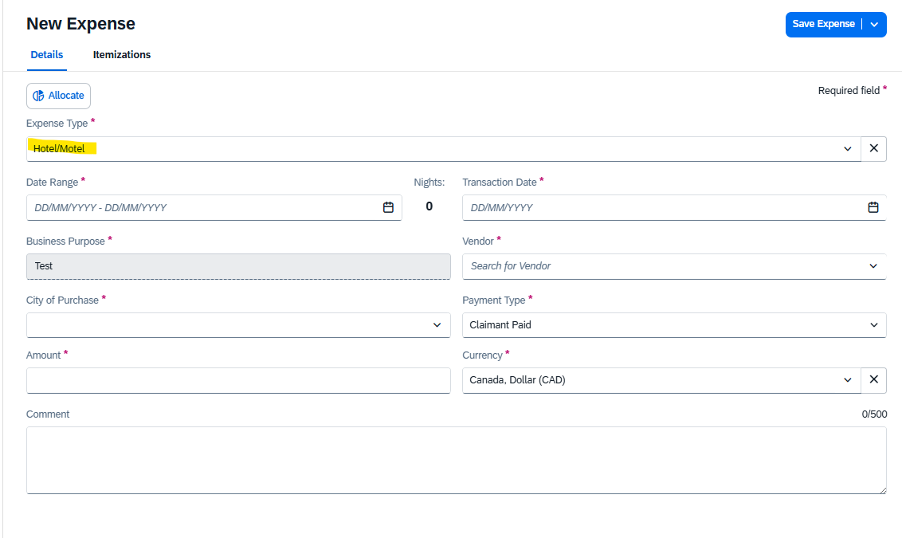
Enter information, including total amount of hotel expense
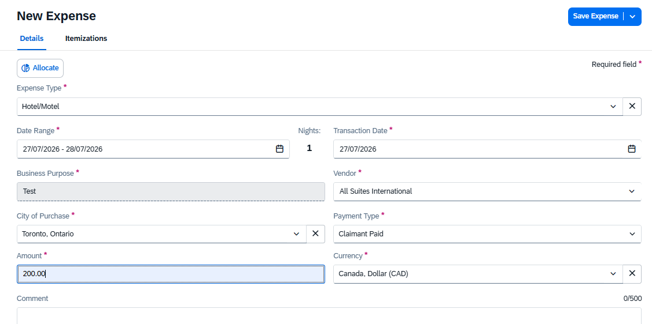
Click Itemization tab
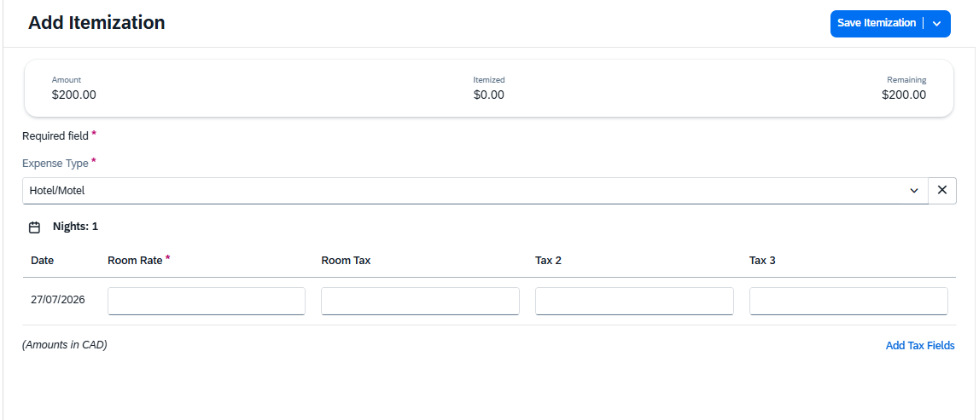
Add itemizations by using pull down within Expense type. It is easier to do the other charges first.
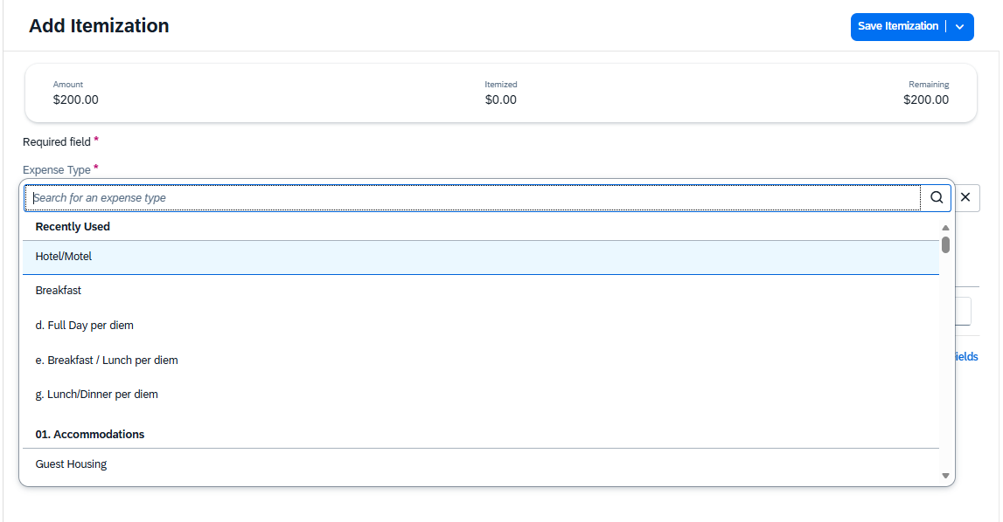
If the itemization is personal, please click box and then save.
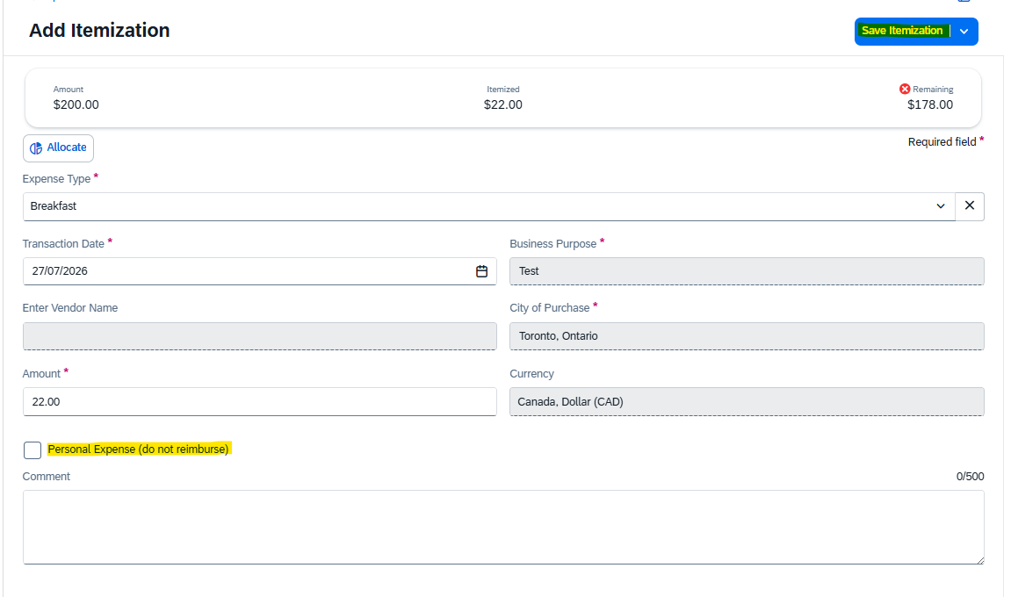
Click add Itemization to add another expense.
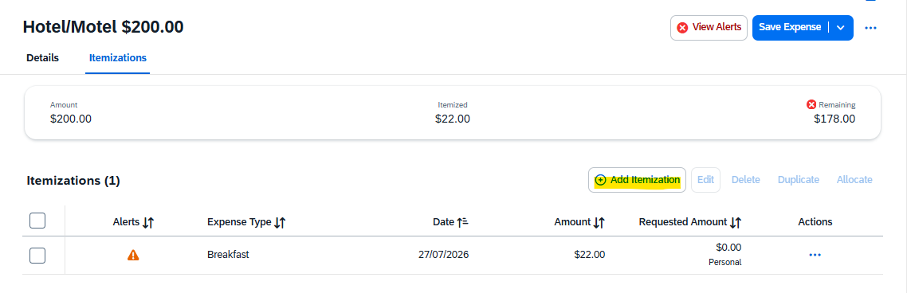
Add the remaining amount and click Save Itemization.
