Changes to PeopleSoft because of the upgrade.

- The default menu sorting is now alphabetical.
To change the sorting back to standard sort, follow the below.
- Click on the navigation icon and select the settings button beside ‘NavBar’.
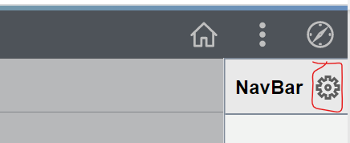
Click on the ‘Standard’ button under the Menu Order menu then click the save button.
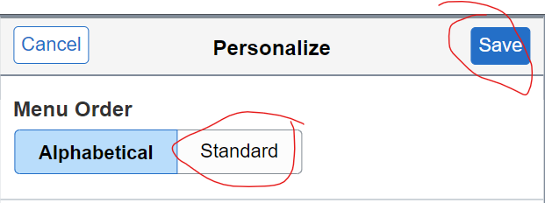

- Recently Visited and favorites now showing on the left panel.
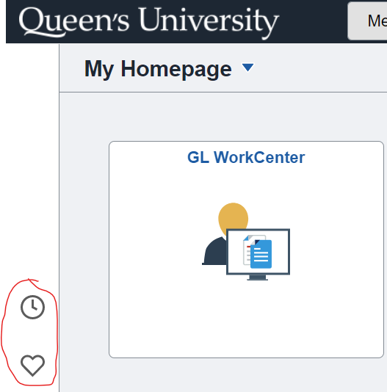
- When running processes on the journal entry page a new popup is displayed.

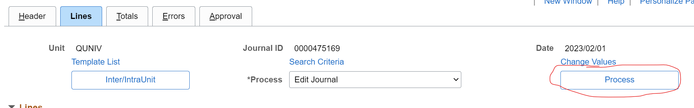
Below is the new popup
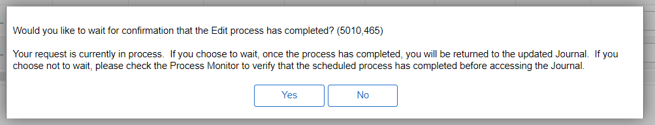
Click yes to stay on the page and wait for processing to finish, click no to return to the journal creation/search page.

- Nav changes for AR/Billing users
Old Navigation Name | New Navigation Name
Customers > Customer Information >General information | Customers > Customer Information > Create Customer Information

- There is a new template for journal uploads, a separate communication will be sent to users with spreadsheet journal upload access.

- Personalizing journal entry fields

In order to personalize the journal entry page after the upgrade you now need to select the grid action button located on the left-hand side of the lines section and then the personalize link. The process to personalize your columns after that remains the same as before the upgrade.
