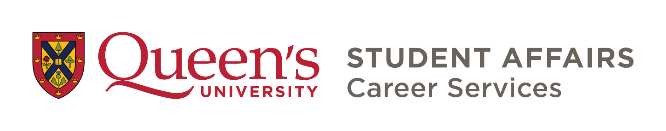

INDIVIDUAL DEVELOPMENT PLAN (IDP)
STUDENT WORKBOOK

Contents
Making a Map to Your Future 2
Your Personalized Route for Success 2
The IDP Process 2
IDP Deliverables and Timing 3
Taking Your IDP further with Social Supports 4
1.0 VISION PHASE 5
1.1 Where do you want to go? Setting Career Direction & Goals 5
1.2 Researching Career Options 7
1.3 Where are you now? Assessing YOUR Skills & Experience 9
1.4 How are you going to get there? Setting development goals 11
1.5 Set the stage for success 15
2.0 ACTION PHASE 16
3.0 REFLECTION PHASE 16
4.0 TELL YOUR STORY 17
4.1 Skills Inventory 17
4.2 Deep reflections on your graduate experience 20
4.3 Key Messages 21
4.4 Where do you go from here? 22

Making a Map to Your Future
Congratulations on getting more intentional about your development as a professional. The Individual Development Plan (IDP) process has been designed to provide direction, support, and tools to help you:
- Set flexible career goals that align with your values, skills, and interests, with awareness of job-market options and realities
- Identify strengths, gaps, leverage resources, and make plans to build additional learning experiences into your graduate education to move you closer to your goals
- Complete your degree and successfully transition from education into the next stage of your career, ready to tell compelling stories about your graduate experience

Your Personalized Route for Success
The IDP process is based on the concept of professional development plans from the world of work, in this case applied to your education. While your graduate experience will offer many opportunities for growth and learning, working on your IDP is your chance to further customize your experience and ensure it is helping you get where you want to as a professional. Through professional development planning, you will articulate career goals, develop plans to achieve them, and track your successes along the way. These goals can happen both in and out of the classroom, and could include:
- Developing additional skills, knowledge, and qualifications
- Gaining insight and experience in a specific industry or sector
- Building a professional network in a new arena
Having a clear direction and purpose can help you stay engaged through the ups and downs of your education, have more effective relationships with your supervisor, and gain satisfaction from achieving your goals.

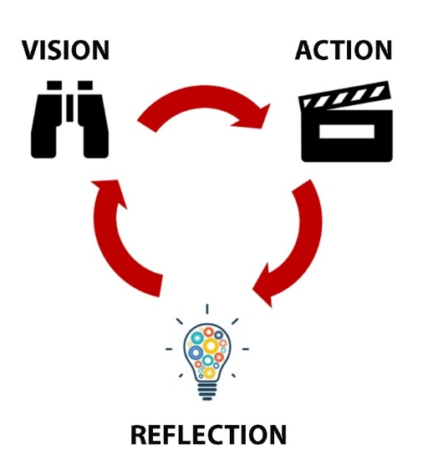
The IDP Process
Experiential Learning Theory suggests that we cycle through phases of action and reflection throughout the learning process. These phases are integrated into the IDP process, much like the research process, but in this case the research project is YOU.
We start the process with VISION: an opportunity for some initial reflections on where you are now and where you want to go. Then, set some goals for the year ahead. Throughout the year, you will be in ACTION to track your progress. Finally, we will move to REFLECTION to look back at how you’ve grown.

IDP Deliverables and Timing
This process can be repeated annually throughout your degree to help you pivot and move towards new professional goals. At the end of your degree you will be encouraged to refine your ability to tell your graduate story to potential employers and other audiences.
Year One
Phase | Stage | Deliverables | Schedule | Optional Supports
VISION | - Career Goals & Vision | • Exercise 1.2 Careers of Interest Sketch | First month of program | IDP Launch Workshop – Career Services and SGSPA
 | - Assessing Skills & Experience | • Exercise 1.3 Initial Skills Assessment
 | - Setting Development Goals | • Worksheet 1.4 Annual PD Plan
ACTION | - Tracking Progress | • Implement IDP goals  • Tracking notes on Annual PD Plan  • Mid-year review | Intermediate months (4-6 months) | Mentorship from supervisor, peers or Career Advising from Career Services
REFLECTION | - Year End Review | • Final update of Annual PD Plan | Final month of year (8-12 months) | Go to TELL YOUR STORY phase if completing program.
Successive Years (if applicable due to multi-year degree)
Phase | Stage | Deliverables | Schedule
VISION | - Revisit Vision Phase | • Review both Careers of Interest and Initial Skills Assessment to make necessary changes  • Begin next annual IDP process with NEW Annual PD Plan | First month of program
ACTION | - Tracking Progress | • Implement IDP goals  • Tracking notes on Annual PD Plan  • Mid-year review of progress and pivoting as necessary | Intermediate months
REFLECTION | - Year End Review | • Final update of Annual PD Plan | Final month of year

IDP Wrap Up - Final Capstone Reflection (near end of program/year)
Phase | Deliverables | Schedule | Optional Supports
TELL YOUR STORY | • Complete Skills Assessment exercise  • Deep reflection questions worksheet  • Complete Storytelling worksheet | Final months of program | IDP Wrap workshop through SGSPA/Career Services

Taking Your IDP further with Social Supports
The IDP process can be even more powerful when integrated with an ongoing mentoring relationship such as a research supervisor, peer, or learning cohort.
If you have a supervisor who wants to support you in the IDP process, encourage them to refer to the IDP Guide for Supervisors (on the IDP webpage). It provides some guidance the 3 conversations they are requested to have with you throughout your IDP (at the beginning, middle, and end).

1.0 VISION PHASE

1.1 Where do you want to go? Setting Career Direction & Goals
To get the most of the IDP process, you’ll need to have some possible career directions in mind. These will inform areas for growth and development throughout your degree. To help, we will explain a few key career concepts and then go through the career direction worksheet.
Where can YOUR degree take you?

Common Pathways Beyond Academia
- Nonprofits, Foundations, and Institutes
- Arts Administration
- Publishing and Media
- Teaching
- Higher Ed Administration (and alt-ac)
- Government
- Research
- Consulting
- Tech companies
- Entrepreneurship

You might be surprised! With academic graduate programs for example, many people assume the main career pathway is to work in academia – but the truth is less than half of graduate students end up working in a university. The same applies for professional programs – even for something as focused as Law. A quick search for your program of alumni on LinkedIn can show you that usually graduates end up in careers not directly related to their degree more than 50% of the time (see sidebar for examples).
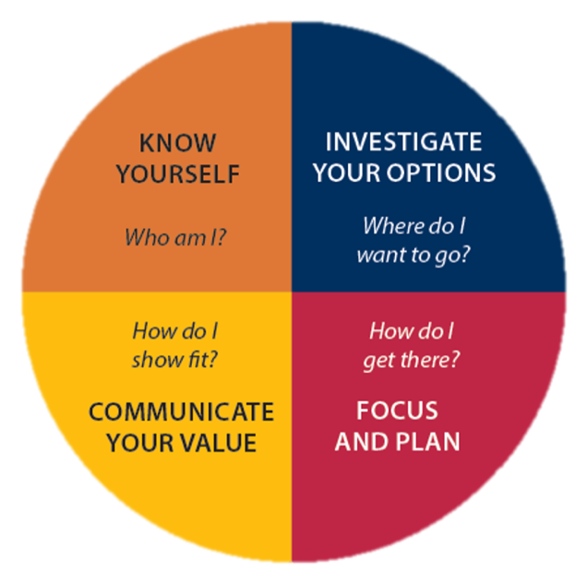
Why is this? Because you are much more than your degree, with diverse skills, experiences, interests, and values that can take you in diverse directions – and the skills you learn in school can be applied to many settings. So, while the popular options are worth considering, it’s important to know it is possible to take your talents in new directions too!
Career Planning 101
The core components of career planning include knowing yourself, exploring options, making plans, and effective communication. By reflecting on your strengths, values, and interests, and keeping these in mind while you investigate options you can make more informed career decisions and plans, and convincing applications. The IDP process will help you to develop this self-awareness.
Modern career theories like Chaos Theory of Careers remind us that the world is a complex, dynamic place – and we need to plan accordingly. Rather than rigid plans, we are best positioned to handle change with flexible goals, contingency plans, and loose career directions that allow us to pivot as we change, the world changes, and new information comes to light. By working toward goals that are meaningful to us, we can learn, grow, make connections, and adapt in our future decisions about where to go next.
Investigate Your Options
Design Thinking is a theory that suggests we make better decisions when we begin by considering more than one option. To support your IDP planning, you will need to come up with 4 career possibilities of interest to you. It might help to think of these as Plan A (perhaps your current, most serious idea), Plan B (a backup plan), and then 2 other ideas that are more open, creative, or something you’ve always wanted to try. Remember, you are allowed to change your mind!
If you need help thinking of possible career directions, you might want to consider:
- Using tools like the Alumni Search on LinkedIn to get ideas of other pathways (search for Queen’s and then click on the alumni tab)
- Looking at the careers tab in www.careercruising.com (login: career, password: golden)
- PhD career resources like:
  - https://www.imaginephd.com/
  - https://fromphdtolife.com/resources/
  - https://intersectjobsims.com/
- Self-reflection activities like reviewing your past experiences for themes, or mind-mapping to explore possibilities and interests
- Consider completing online assessments and tools like:
  - Life Values Inventory — Values Clarification Program
  - VIA Character Strengths Survey & Character Reports | VIA Institute
  - Consider the UN SDGs to explore interests Home | Sustainable Development (un.org)
- Reading books like Design Your Life and So What Are You Going to do With That? available at Career Services in the Career Information Area
- Book a career consultation at Career Services to help generate possibilities
Exercise 1.1 Please use this space to brainstorm career possibilities. When you are ready, take your top 4 ideas to the Exercise 1.2 on page 8.

1.2 Researching Career Options
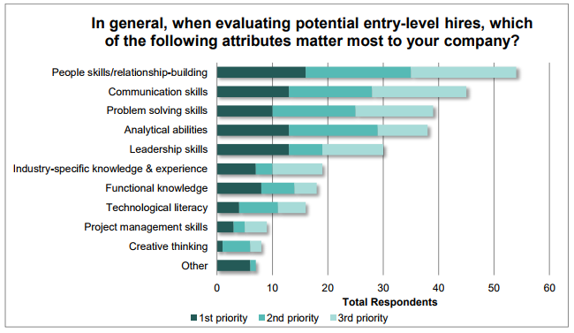
Once you have a short list of occupations of interest, it’s time to do a little digging and learn more about the requirements for those fields.
Before we start – a short note about skills. While technical and job-specific skills and knowledge might come to mind immediately when thinking about job requirement, employers consistently rank transferable skills at the top of their lists for “hireability” (Canadian Council of Chief Executives Survey 2014 shown right).
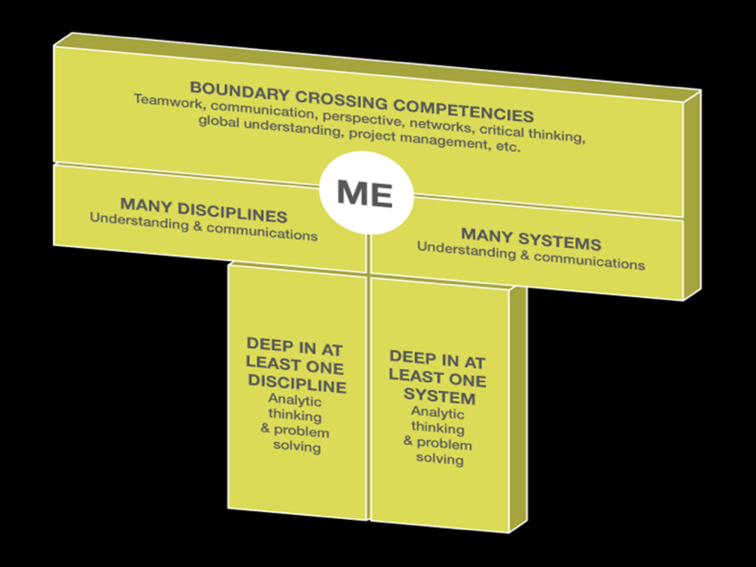
This doesn’t mean that the discipline-and system-specific knowledge you’re working hard to acquire doesn’t matter. In fact, what this tells us is that they BOTH matter; employers are looking for breadth AND depth. The T-Shaped professional (see diagram) refers to someone who has a strong foundation in professional transferable skills like collaboration and problem-solving, as well as technical or job-specific skills in their field of interest.
The good news is that graduate school helps you develop both of these dimensions. While it is common to think of graduate school as a place that focuses on deep discipline-specific knowledge, it also helps develop advanced transferrable skills like project management, collaboration, and more. The trouble is that these fundamental skills and learning often happen unnoticed in the background. The IDP process helps to bring attention to these areas to help you articulate the value of how you’ve grown, and identify areas for development in relation to your career goals.

To learn more about the specific requirements for your short list of potential careers, consider:
- Career Cruising: is a free occupational information database where you can learn more about careers and link to other useful resources at www.careercruising.com (Queen’s login: careers, password: golden).
- Job postings: try searching sites like Eluta, Indeed, or Monster, as well as specific organizations for opportunities to learn more about requirements in the field
- LinkedIn: read profiles of people working in areas of interest to learn about their skills, experience, and qualifications to help you draw your own road map
- Professional Associations: can be a valuable source of information with resources specifically for people looking to enter the field, as well as their own job listings, conferences, and more. To find them try googling the occupation, the word “association”, and your region – like “editors’ association of Canada”, which would bring you to Editors Canada.
- Information Interviews: By interviewing people working in fields of interest, you can learn from insiders and build your professional network at the same time. For more on this, read the Career Services tipsheet here: Tipsheets | Career Services (queensu.ca)

Exercise 1.2 Careers of Interest Sketch
For your top 4 careers of interest from 1.1, record your key findings below including skills, knowledge, qualifications, and experience required for each possibility.
Career 1: ___________________________

Career 2: ___________________________

Career 3: ___________________________

Career 4: ___________________________

1.3 Where are you now? Assessing YOUR Skills & Experience
Now it is time to turn your attention inward and examine yourself. Where are you in terms of your development as a professional? In this section we examine your skills: existing strengths and areas to target for development. To provide a framework and shared vocabulary we will be drawing on the Queen’s Skills Cards which feature the following skills:

- Accountability
- Actively anti-oppressive
- Adaptability
- Advocacy
- Analysis and synthesis
- Attention to detail
- Civic participation
- Community building
- Community engagement
- Creative expression
- Creativity
- Critical thinking
- Customer service
- Empathy
- Ethics and integrity
- Financial literacy
- Fostering inclusion
- Global perspective
- Identity development
- Indigenous cultural awareness
- Indigenous ways of knowing
- Initiative
- Intercultural skills
- Interpersonal skills
- Maintaining health and wellness
- Marketing
- Mentoring, coaching, and advising
- Navigating group dynamics
- Networking
- Oral communication
- Organization and time management
- Persuasion
- Problem solving
- Project management
- Research
- Resilience
- Self-improvement
- Self-management
- Supervising and leading others
- Teaching and facilitating
- Teamwork
- Understanding leadership styles
- Utilizing technology
- Writing
To learn more about each skill, visit the skills cards online here: https://careers.queensu.ca/skillscards.
Adding your customized skills to the list
You may want to add to the list above with specific skills, knowledge, and qualifications you want to consider your skills assessment in Exercise 1.3 (such as those you have found in your research from Exercise 1.2). These can be skills you currently have and/or skills you want to develop.
Please summarize the key points below for incorporating into the exercise in Exercise 1.3.

Exercise 1.3 Initial Skills Assessment
In this exercise, you will draw on the Skills Cards framework and the additional skills you added to complete the 4-quadrant model. Consider how proficient you are at each skill, how necessary the skill is for your careers of interest, and take note of any surprising revelations. Then transfer the skills in the Development Targets to your Annual PD Plan in the Skills I Might Need section. You can complete the skills sort on the worksheet below, or ONLINE here Queen's Skills Cards | Career Services (queensu.ca) (if you do the online sort, be sure to note the key points below in each quadrant).
Highly Proficient

Untapped Strengths
(High proficiency, Low Demand)

Existing Strengths
(High Demand, High Proficiency)

Low Demand
High Demand
Minimal Attention
(Low proficiency, Low Demand)

Development Targets
(High Demand, Low Proficiency)

Low Proficiency

1.4 How are you going to get there? Setting development goals
Armed with a better understanding of your priority areas for learning, it is now time to get more specific. How will you achieve this? How will you know you have been successful? In this section, you will construct detailed professional development goals—these are at the heart of IDP process.
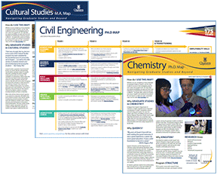
We encourage you to consider at least one goal in each of the 5 professional development tracks from the Grad Map framework to help you ensure a well-rounded education that positions you for success following graduation:
- Achieve Your Academic Goals: learning related to core academic skills required for success in your coursework
- Maximize Scholarly Impact: learning related to the application of your studies through research, practicum, or otherwise
- Build Skills and Experience: learning beyond the student experience through work (including teaching and research), volunteer, or extracurricular activities
- Engage with Your Community: goals related to building your network, establishing a presence, and contributing to your communities
- Launch Your Career: career development goals such as occupational research, self-assessments, information interviews, career planning, or developing professional job search documents
To assist you in brainstorming ways of meeting your development goals consider the following:
- Explore the specialized offerings from Queen’s School of Graduate Studies such as sessions through SGSPA, or Career Services.
- Talk to peers, supervisors, and professionals working in fields of interest for suggestions
- Review the Grad Map for your program at https://careers.queensu.ca/gradmaps
Common activities for professional development:
- Volunteering & extracurricular activities, Internships and experiential learning projects
- Pursuing additional certificates and courses (Colleges & Associations)
- Workshops and training
- Adding projects/components to existing jobs/research

How do we actually develop our skills?
Consider the following model as you reflect on where you are at with the specific skills that you want to develop. It can give you clues as to what types of learning activities you might most benefit from at your stage of growth.
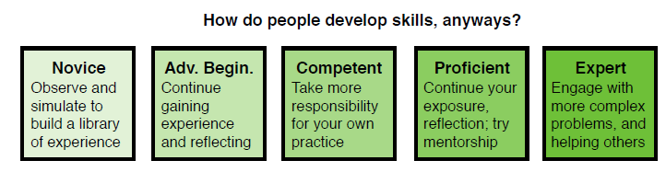
Analytical Intuitive

- It is possible to get stuck in the middle – you may benefit from learning community
- Without continued practice, regression is possible
Getting specific about YOUR needs can give clarity on next steps
As you get more advanced, it may be that you would most benefit from fine-tuning by focusing on specific aspects of a skill that are holding you back from reaching the next level. The first step might be learning more about the skill in question.
Consider a common skill that people often want to develop – collaboration. According to the Conference Board of Canada, COLLABORATION includes being able to:
- understand and work within the dynamics of a group
- ensure that a team’s purpose and objectives are clear
- be flexible: respect, and be open to and supportive of, the thoughts, opinions, and contributions of others in a group
- recognize and respect people’s diversity, individual differences, and perspectives
- accept and provide feedback in a constructive and considerate manner
- contribute to a team by sharing information and expertise
- lead or support when appropriate, motivating a group for high performance
- understand the role of conflict in a group to reach solutions
- manage and resolve conflict when appropriate
If you were trying to improve you might realize that you are strong at some aspects, but really need to focus specifically on one aspect, like managing conflict or understanding dynamics.
By reflecting on your unique situation, competencies, and needs, you can make specific meaningful learning goals that are most likely to help you grow in ways you most need it.
Exercise 1.4 Learning Goals
Complete the following worksheet to help you clarify your goals. Remember the SMART framework (specific, measurable, attainable, relevant, time-based) to ensure a well-structured goal. Once you’ve answered these questions, you can create specific goals on your Annual PD Plan document on the following page.
Learning Goals:  What do I intend to learn? | Rationale:  Why is this important? | Learning Activities:  How do I learn best? Which activities will help? | Assessment Criteria:  How will I know I’ve achieved my goal? | Support/ Resources Required:  What additional resources or supports are there?
SAMPLE:  Public speaking skills | Need it for media and teaching work | Workshops and practice | Speaking with confidence, receiving positive feedback | 3MT Competition, Public speaking workshops from SGSPA
Adapted from HEQCO, “A Practical Guide for Work Integrated Learning (2016)

Worksheet 1.4 Annual PD Plan
Use this page as the central tracker of the results of the previous activities in Exercise 1.2, 1.3, and 1.4, as well as tracking your future results from the action and reflection phases.
Academic Year: ________________________
Goals (3-5) | Development Goals | Results | After Graduation
CAREERS OF INTEREST (from 1.2)

1.

2.

3.

4.

SKILLS & QUALIFICATIONS
I MIGHT NEED
(from 1.3)

1.5 Set the stage for success
We asked past participants for advice to help you get the most out of your experience. Here’s what they had to say:
Keep your eye on the skills you want to develop.
- Search for opportunities which pertain to skills you lack. There are many options out there which you may have trained yourself to overlook.
- Use it to "ground" your ideas about your skills and how they relate to your career goals.
What’ll really help is a focus on goal setting and tracking.
- I would suggest they print out the pages on which they articulated their concrete goals and the steps they will take to reach those goals. Tape those pages up near your desk.
- I would tell them that it's really important to come back to your goals written in your workbook and look in what you should participate to realize them.
- They should dedicate 25-30 minutes every week to engage with the materials of the IDP workshop and self-reflect on their skills, goals, and interests.
Use it to focus / maximize time with your supervisor.
- Take advantage of this time with your supervisor! If you're anything like me, most of my regular sessions with my supervisor are spent discussing my dissertation or grant proposals, so this was the perfect opportunity to talk about what comes after graduation.
- Meet with your supervisor as much as possible and discuss all the aspects of the IDP to them. They may have very valuable information or advice on potential career paths!
- Don't be afraid to bring career options that are outside of academia to your professor in your conversations. This will help them understand your intended trajectory and they can assist you in reaching those goals.
Consider it a parallel process to other graduate learning & give it the time it needs / deserves.
- I would suggest they view it as a parallel process with traditional PD activities (like publishing) and, as such, that they dedicate a significant portion of PD time to this process.
Commit to it / take it seriously.
- Lean into it! think seriously about your skills (give yourself credit!) and acknowledge where you could improve. Track your goals over the year. You'll be surprised at what you can achieve.
- Complete the whole workbook and take it seriously. Explore all the resources, and do this regularly, not just a one-time thing. Discuss with supervisor and career counsellor even once the IDP process is complete.
- Future advice would be to take the entire process seriously and consider what you what in the future. I found it extremely helpful when I put in the time and spoke with other students about the process.
Say “yes” and build community.
- Participate in all the workshops and communicate with other phds.
- Work on your plan between sessions, find an IDP buddy.
- I think to really know that it is about what you put into it and that you should engage more with the facilitators because they are here to help!

2.0 ACTION PHASE
Throughout the year (especially at mid-point), be sure to take notes on your progress towards your goals. This will help you write your year-end reflection, describe your PD activities to your supervisor or future employers, and set more effective future goals. Record your notes in the “Results” column of Worksheet 1.4 Annual PD Plan. Consider the following questions in recording your results:
- Are there measurable results I can record here? Evaluations, completed activities?
- What is working well? What have I learned?
- What needs adjusting? Do I need to change my plans?
SAMPLE: | Development Goals | Results
Goal 1. | Complete 3 SASS workshops on academic writing and study skills in the fall semester of first year. | Completed 2 of 3 workshops by November. Learned about procrastination and scholarly writing basics. Realized an appointment would be more useful than third workshop; have set one up for next week.

3.0 REFLECTION PHASE
At the end of the year, it is time to look back and be sure you have captured all of the results of your professional development work for the year, revisiting the questions in section 2.0. This is an excellent time to meet with your supervisor or mentor to discuss your progress to date. Consider the following questions:
- How did these experiences change me? What do I do or see differently now? How will I apply it in the future?

- What was the most significant thing about this experience from the perspective of a potential employer? How could this experience help me make a bigger contribution?

- Did it reveal any areas for future growth? Certain skills or knowledge that I want to improve? What goals might I set to grow in these specific areas?

This concludes the annual portion of the IDP process. From here you will either revisit phases 1-3 annually, or if you are completing your degree/IDP, move on to phase 4 – the Capstone reflection. Additional copies of the Annual PD Plan can be found in the appendix.
4.0 TELL YOUR STORY – Get ready to launch your career…
Congratulations on nearing the end of your degree. As you prepare for your next steps in your career, a final reflection now can help you take stock of your graduate experience to:
- Make informed decisions about what is next in your career
- Have an internal narrative to help you make sense of your experience
- Develop a compelling story to tell networking contacts
- Craft job search documents like resumes, cover letters, and LinkedIn profiles
- Perform your best in interviews
To guide you we have 3 final activities: a skills assessment, a set of reflective questions on your graduate experience, and a summative activity of your 3 key messages.

4.1 Skills Inventory
Some graduate students struggle to translate the value of the skills they have learned in academia into language meaningful to future employers. Take the time now to develop a clearer sense of what you’ve learned, using the employer-friendly vocabulary provided by ranking your competency in the following skill areas. To learn more about each skill, visit https://careers.queensu.ca/skillscards.
Skill | High | Med. | Low | Example or Other Notes
Accountability
Actively anti-oppressive
Adaptability
Advocacy
Analysis and synthesis
Attention to detail
Civic participation
Community building
Community engagement
Creative expression
Creativity
Critical thinking
Customer service
Empathy
Ethics and integrity
Financial literacy
Fostering inclusion
Global perspective
Identity development
Indigenous cultural awareness
Initiative
Intercultural skills
Interpersonal skills
Maintaining health and wellness
Marketing
Mentoring, coaching, and advising
Navigating group dynamics
Networking
Oral communication
Organization and time management
Persuasion
Problem solving
Project management
Research
Resilience
Self-improvement
Self-management
Supervising and leading others
Teaching and facilitating
Teamwork
Understanding leadership styles
Utilizing technology
Writing
Other:
Other:

4.2 Deep reflections on your graduate experience
Consider the following questions as they relate to your entire graduate school experience (not just the IDP itself) to help you tell your graduate story:

- What was the most challenging thing about this experience? How did I overcome it?

- What results or accomplishments came from my work? How did I achieve my goals?

- What impact did I have on those around me, or the environment I was in?

- How did this experience change me? What do I do or see differently now?

- What might be the most significant thing about this experience for a potential employer? How could this experience help you make a bigger contribution in future work?

- What is the biggest thing I learned? Why does it matter? How will I apply it in the future?

- Did it reveal any areas for future growth? Certain skills or knowledge that I want to improve? What specific goals can I set to grow in these specific areas?

4.3 Key Messages
Telling an effective story requires focus, clarity, and compelling specifics that drawn in the listener or reader. What will be the essence of the story you tell about your time at Queen’s? In this final activity, you are invited to focus on 3 key messages that are most significant about your experience, and to your potential audiences. In each message, consider what examples or stories you might tell to provide evidence for your point, drawing on your reflections in exercises 4.1 and 4.2.
Key Messages  (skills, knowledge, attribute) | Supporting example  (Using context + action + result structure)
SAMPLE:  Project Management | When I began my PhD, I was overwhelmed by how much I had to do, and in such a short time – it was the most complex project of my life! Not only did I have to complete my initial coursework, but my initial research direction ran into complications, and I had to make a drastic change of direction that required developing new skills in coding on the fly. I targeted project management in my IDP as a key skill to develop and took a course from MITACS. This helped me develop key tracking documents and better communicate my progress with my supervisor. In the end, I still managed to complete in my original timeframe despite the unforeseen changes of direction!
1.

2.

3.

4.4 Where do you go from here?
While this exercise will lay a foundation to prepare you to connect with others going forward, it is important to keep in mind that your messaging and branding needs to vary depending on the needs of your audience. For help with this, consider taking advantage of support from the School of Graduate Studies and Career Services with resumes, cover letters, interviews, LinkedIn, and networking through workshops, drop-in advising or career consultations. Additionally, if you need assistance making career decisions, or strategizing about your job search going forward, please consider a career consultation with a career counsellor.

ENDNOTES

Members of the Adolescent Moral Development Lab. “The Psychology of Purpose.” Claremont Graduate University, John Templeton Foundation, 2018, pp. 13. https://www.templeton.org/wp-content/uploads/2020/02/Psychology-of-Purpose.pdf
Kolb, A. Y. & Kolb, D. A. (2011). Experiential learning theory: A dynamic, holistic approach to management learning, education and development. In Armstrong, S. J. & Fukami, C. (Eds.) Handbook of management learning, education and development. 10.4135/9780857021038.n3.
(CFB, Inside and Outside the Academy, 2015)
Susan Basalla and Maggie Debelius, “So What Are You Going to Do with That?” Finding Careers Outside Academia (3rd ed., 2014)
Bright, J. E., & Pryor, R. G. (2005). The chaos theory of careers: A user’s guide. The Career Development Quarterly, 53(4), 291-305. doi:10.1002/j.2161-0045.2005.tb00660.x
Plattner, H., Meinel, C., & Leifer, L. (editors) Design Thinking Research: Measuring Performance in Context. Potsdam, Germany & Stanford, California: Springer Science + Business Media. 2012.
Gardner, Phil & Estry, Doug. “A Primer on the T-professional.” Michigan State University, Collegiate Employment Research Institute, 2017, pp. 1-35. http://www.ceri.msu.edu/wp-content/uploads/2018/03/Primer-on-the-T-professional.pdf

