HALO Image Analysis
How do I access HALO?
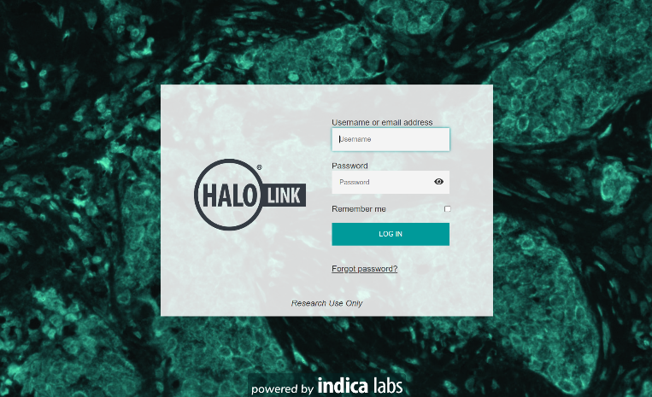
HALO Link is an image management system that allows you to remotely access slides and run image analysis algorithms previously developed in HALO.
HALO Link is accessible through a web browser at https://images.path.queensu.ca/
For algorithm development, the HALO workstation is located at Richardson Lab Rm 401. Remote desktop connection is available for selected users based on request. Calendar for bookings for remote desktop: Link to online calendar
Requesting for access:
- Access to Richardson Lab Rm 401 (Shakeel - virks@queensu.ca)
- Access to HALO remote desktop (Kevin Kell - kevin.kell@queensu.ca)
Want to learn more about image analysis in HALO?
- Check HALO user guides (https://learn.indicalab.com/tag/halo-user-guides/)
- Check Indica Labs online learning portal (https://learn.indicalab.com/) for tutorial videos, webinars and technical documentation
Need help with algorithm development? Contact Nathalia Kim (kim.n@queensu.ca)
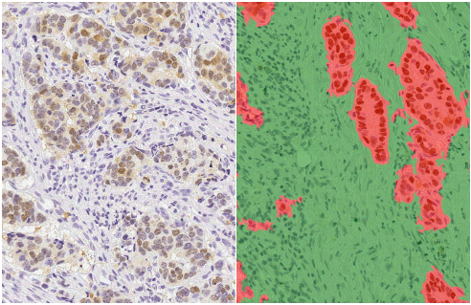
HALO Available Modules/Algorithms
Tissue Classification: Utilizes a state-of-the-art machine learning algorithm to identify tissue types based on color, texture, and contextual features. With a “learn-by-example” approach, the user highlights a few distinct tissue types and the software learns to categorize tissue

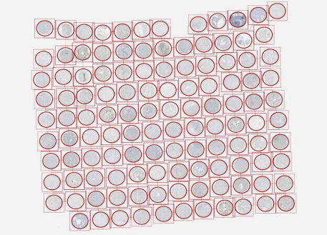
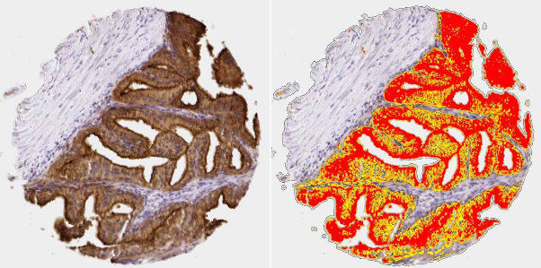
TMA (Tissue Microarray): Provides a productivity-enhancing workflow for tissue microarray analysis by enabling automated, high-throughput, segmentation and batch analysis of whole slide TMA images. It can be used in conjunction with any of the cell-based analysis modules for brightfield or fluorescence, as well as the tissue classifier add-on for automated tumor detection.
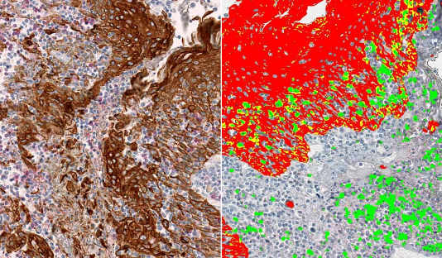
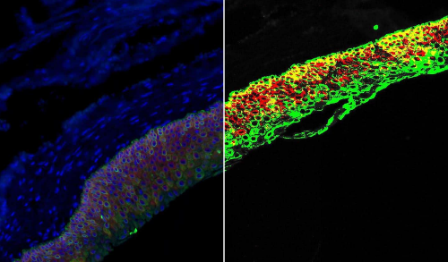
Area Quantification: Quantifies brightfield stains or fluorescent dyes on a per area rather than per cell or object basis. It is a flexible alternative for analyzing tissues where cell structure cannot be readily identified or where tissue area-based outputs are more reliable or meaningful measure. Area Quantification quantifies and reports stain positive area, average stain optical density for each stain, binned positivity based on optical density (0, 1+, 2+ and 3+), and area of colocalization (when multiple stains are analyzed).
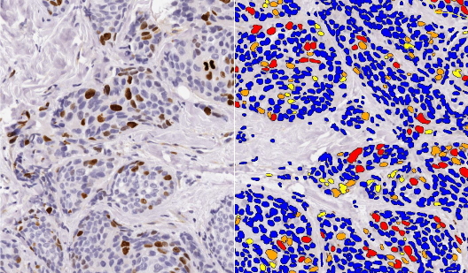
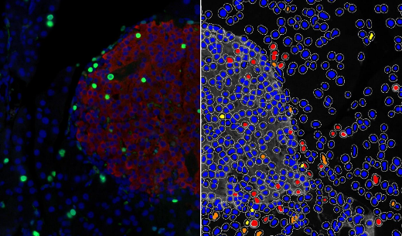
CytoNuclear: The Cytonuclear module measures cell-by-cell positivity for single or multi stain applications. Each cell is measured for cytoplasmic or nuclear positivity of every individual stain as well as the colocalization of different marker combinations. Positive cells are binned and assigned an intensity score (0, 1+, 2+, and 3+) based on stain optical density. The module also reports a variety of other metrics relating to cell/nuclear size and stain intensity. Optionally, the tool can output the complete table of cell data including individual cell sizes and optical density measurements for each stain in each cellular compartment. This module has the option to define specific cell phenotypes according to marker positivity, allowing users to define and count specific cell populations based off of defined positivity and negativity rules.

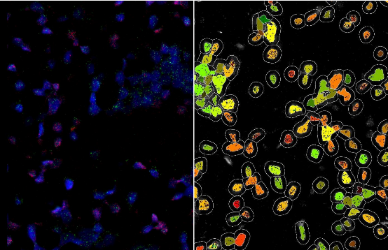
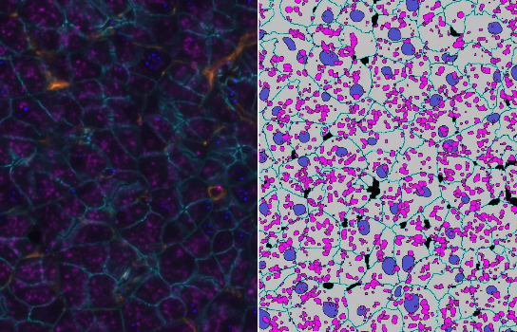
FISH-IF Quantification: The FISH-IF quantification module measures any number of fluorescently-labeled DNA/RNA ISH probes and immunofluorescent (IF) protein biomarkers on a cell-by-cell basis. This allows the user to rapidly contextualize the corresponding protein and gene expression profile of every cell across the tissue. HALO FISH-IF analysis is designed to work with single or dual IHC-ISH assays including RNAscope. In addition, the multiplex FISH module is also available to quantify an unlimited number of DNA or RNA FISH probes on a cell-by-cell basis.

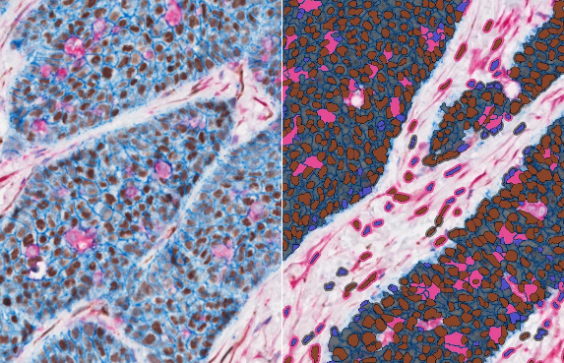
Multiplex IHC: The multiplex IHC module separates up to five stains simultaneously within any cellular compartment (nucleus, cytoplasm or membrane) and can be used for a variety of IHC applications. This module is ideally suited for applications in immuno-oncology where multiple markers are required to characterize distinct immune and tumor cell populations within the tissue. Each cell is individually measured for cytoplasmic, nuclear, and/or membrane positivity. The software also reports a variety of other statistics relating size and staining intensity metrics.

HALO AI: HALO AI is a collection of train-by-example classification and segmentation tools underpinned by advanced deep learning neural network algorithms. HALO AI classifiers can be trained to quantify tissue classes, to segment tissue classes for analysis with other HALO image analysis modules, to find rare events or cells in tissues, and to categorize cell populations into specific phenotypes.
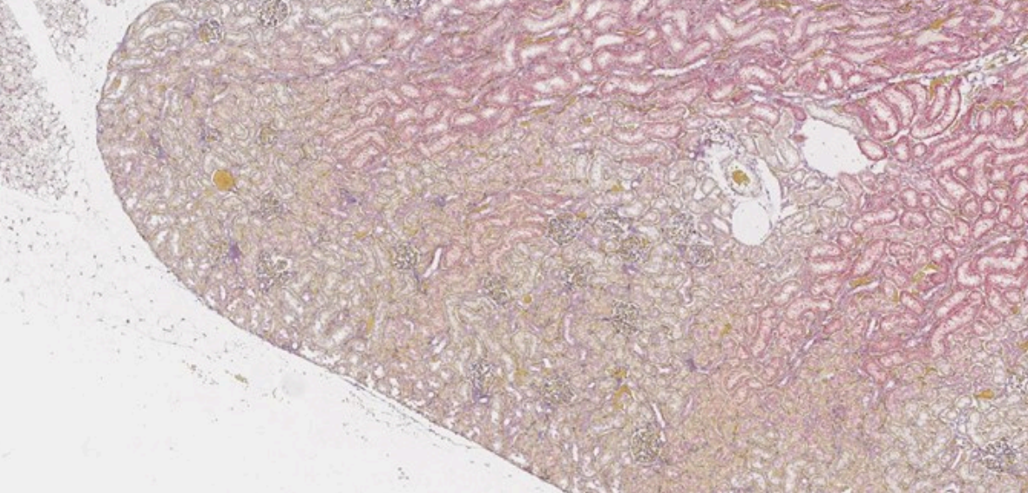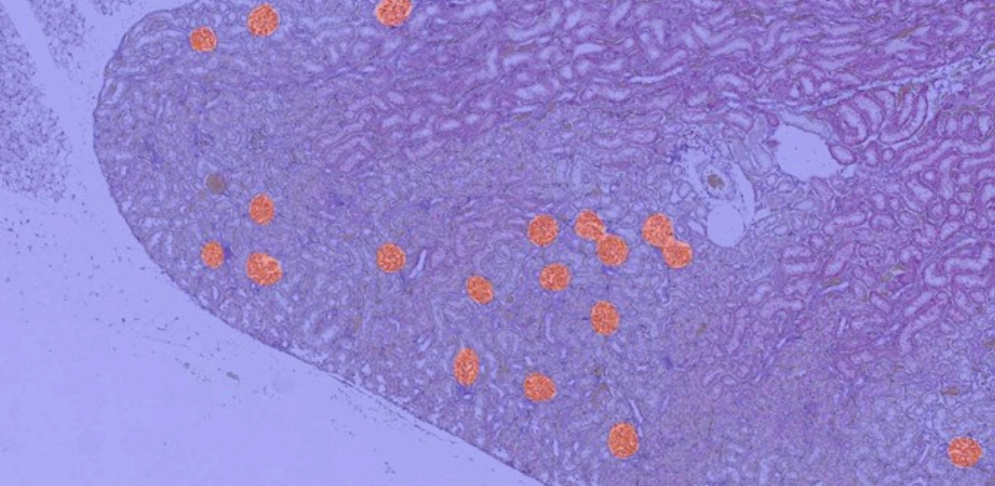
HALO AI glomeruli detection in H&E stained kidney sections
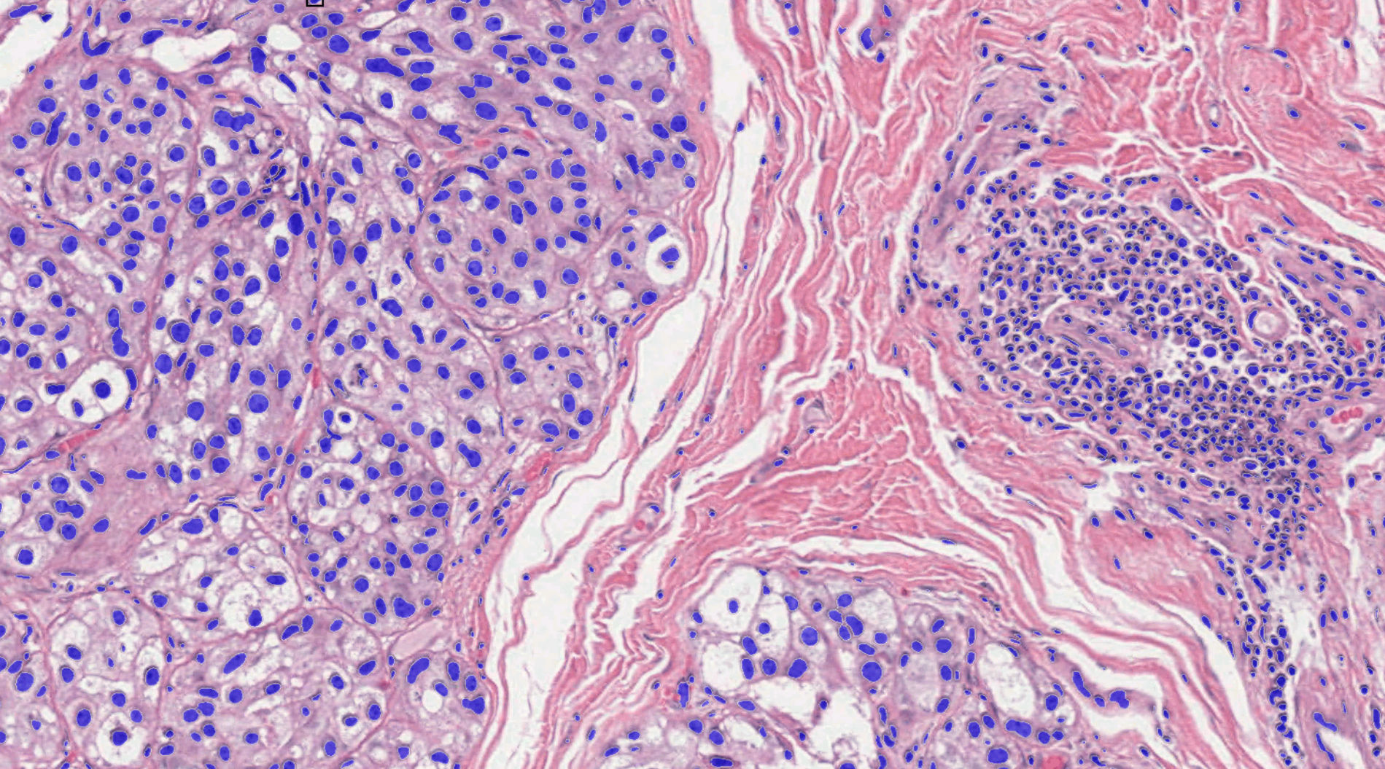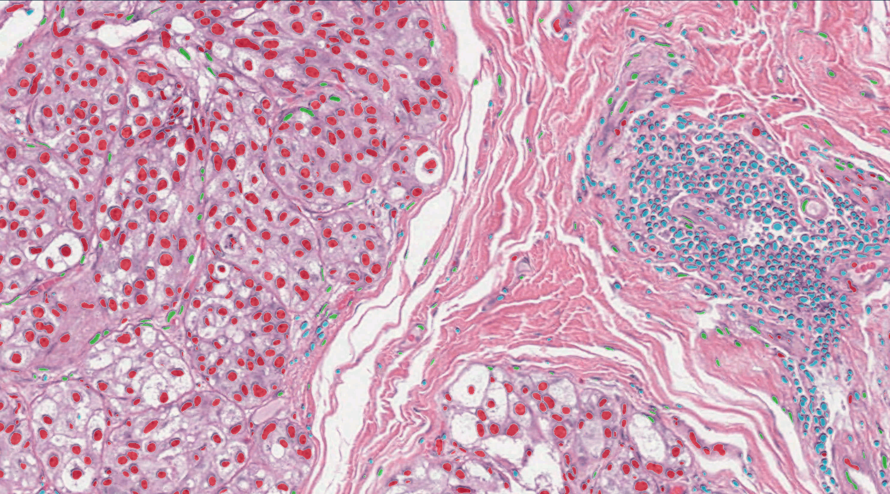
HALO AI cell segmentation and cell phenotyping by marker expression

