Building Name: Click or tap here to enter text.  Room Number: Click or tap here to enter text. |  |  | 
 | 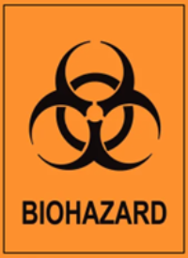
 | CL1
Hazard Type | Additional Information
Biohazard
PPE REQUIRED
 |  |  |  |  | 
EMERGENCY CONTACT INFORMATION
Additional PPE requirements:
Role |  | Name |  | Phone number |  | Office Rm #
PI
Lab Manager
Professor
Lab Tech
EHS Contact Info: Raico Lamela (BSO & RSO) 613-533-6000 x78820 | Natalie Roy (Safety Tech) 613-533-2951 | Tom Martinek (Safety Tech) 613—533-6000 x74976 | General Safety 613-533-2999

