1. Introduction
This procedure outlines the proper methods for the movement and transportation of radioactive materials and substances at Queen’s University.

Purpose: To ensure all radioactive material movements are conducted safely, securely, and in compliance with regulatory requirements.

Objectives:
- Promote safe handling and transportation of radioactive materials
- Minimize the risk of radiation exposure and environmental contamination
- Ensure compliance with CNSC, TDG Class 7, and IAEA SSG-87 standards
- Provide consistent, clear instructions for authorized personnel

Application: This SOP applies to all personnel engaged in the movement or transport of radioactive substances within or outside Queen’s University premises.

2. Scope
This procedure applies to:
- Internal movement of radioactive materials between laboratories on campus
- Off-campus transportation to other licensed institutions or disposal facilities
- All research and teaching activities involving radioactive substances

3. Applicable Legislation, Standards, Guidelines
- Transportation of Dangerous Goods Regulations (TDGR), Class 7 (Radioactive Materials)
- CNSC Packaging and Transport of Nuclear Substances Regulations, 2015
- Queen's University Radiation Safety Manual
- IAEA Safety Standards Series No. SSG-87, Section 10
- IAEA Safety Standards Series SSR-6 (Rev. 1)

4. Responsibilities

4.1 Responsibilities of Directors, Department Heads, and Managers
- Ensure hazard assessments are completed for all areas under their authority
- Implement this SOP in all facilities they oversee
- Ensure relevant staff and students are trained in accordance with this SOP

4.2 Responsibilities of Permit Holders
- Understand and communicate hazards in their respective areas
- Ensure all staff/students are aware of hazards and trained in safe transport procedures
- Verify proper use of packaging, labeling, and safety equipment

4.3 Responsibilities of Staff and Students
- Familiarize themselves with this SOP and receive required safety training
- Follow all instructions for safe packaging and transport
- Immediately report any spills, exposures, or unusual incidents to a supervisor or RSO

5. Definitions
- Radioactive Material: Material that emits ionizing radiation and is regulated by the CNSC
- Transport Index (TI): Number representing radiation level at 1m from a package
- UN Number: Code identifying hazardous material during transport
- Consignor: The sender of the radioactive material
- Consignee: The receiver of the radioactive material
- RSO: Radiation Safety Officer

6. Safety Precautions
- Use certified lead/plexiglass shielding containers
- Personal Protective Equipment (PPE): lab coat, gloves, safety goggles
- Use elevators rather than stairways
- Never transport radioactive materials in personal vehicles
- Emergency spill kits and radiation survey meters must be available (Appendix 1 – Emergency Procedure for Spills and Exposure to Radioactive Material – Queen’s Radiation Safety Manual page 27)

7. Work Practices

7.1 Internal Transfers:
- Verify receiving lab has an internal radioisotope permit.
- Notify the Radiation Safety Officer about the transfer of the source and provide a copy of a Nuclear Material and Device Transfer Log (Appendix A this SOP)
- Package material in secondary containment and shielded carrier.
- Dispersible sources (e.g. radioactive liquids) should be housed in a sealed container that includes sufficient absorbent material to keep any spill within the containment system.
- Label package with isotope, activity, and "Radioactive" symbol
- Containers should be moved on a cart or trolley under the direct supervision of an authorized person.
- Update inventory logs in both sending and receiving labs. (Appendix B this SOP)
- Recipient must perform contamination monitoring on arrival as per Appendix 12 Contamination Measurement – Queen’s Radiation Safety Manual page 57. Keep the records
- Open the packages following the guidelines for handling packages containing unsealed nuclear substances (Appendix 20 – Queen’s Radiation Safety Manual page 80)

7.2 External Transfers:
TDG Compliance: All nuclear substances and radiation devices must be packaged and shipped according to TDG - Class 7 regulations. The RSO maintains this certification and can provide guidance on compliant packaging and shipping procedures.

- Obtain RSO authorization and confirm recipient licensing.
- Package in Type A/B/C containers per CNSC classification
- Label packages with UN number, Radioactive Category I/II/III label, and TI
- Complete and include TDG Shipper’s Declaration
- Use trained/licensed HAZMAT transport providers.
- Maintain emergency contact information and placard vehicle as required.
Additional Considerations
- Transfer Log: An example of the required information in a nuclear substance and radiation device transfer log is available in Appendix A this SOP.
- Regulatory Compliance: In addition to TDG regulations, licensees must also comply with the Packaging and Transport of Nuclear Substances Regulations, 2015 when transporting radioactive materials.
- Delivery Restrictions: Nuclear substances and radiation devices can only be delivered to locations pre-approved by the applicant. This includes providing a complete list of these sites (building name, address, and directions) to the supplier of the materials.

7.3 Inventory Management
- Recordkeeping Requirements: Accurate inventories of nuclear substances and radiation devices are essential. This includes any material in use, storage, or awaiting disposal. Records must be maintained in the areas where the materials are located and should include details such as:
  - Name of the nuclear substance
  - Quantity of nuclear substances
  - Physical form of nuclear substance (e.g., solid, liquid)
  - Location of the nuclear substance
  - Date of receipt
  - Name, address, and license number of the supplier (if applicable)
  - Model and serial number of the radiation device (if applicable)
7.4 Transfer Documentation
- Complete Transfer Records: Comprehensive records must be maintained for all transfers or disposals of nuclear substances and radiation devices. Required transfer record details include:
  - Name of the nuclear substance
  - Quantity and form of the nuclear substance
  - Model and serial number of each sealed source (if applicable)
  - Model and serial number of the radiation device (if applicable)
  - Activity associated with the radiation device (if applicable)
  - Date of transfer or disposal
  - Recipient's name, address, and CNSC license number
  - Name and address of the destination
  - Verification of safe arrival

8. Training Requirements
- Radiation Safety Training (initial and annual refresher)
- TDG Class 7 Transportation Certification
- Site-specific radiation emergency response training

9. References
- Queen’s University Radiation Safety Manual
- CNSC Packaging and Transport of Nuclear Substances Regulations, 2015
- Transportation of Dangerous Goods Act and Regulations (Class 7)
- IAEA Safety Standards SSG-87 (Section 10)
- IAEA SSR-6 (Rev. 1)

10. Revision History
Date | Revised by | Changes
05/21/2025 | Raico Lamela | Format and Sections content updated

11. Appendix
- Appendix A: Internal Transfer Log Sheet
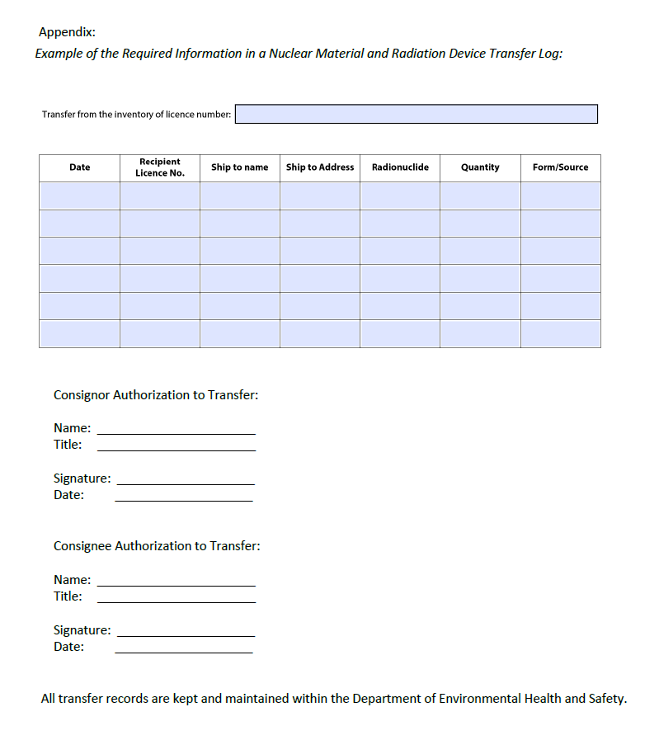

- Appendix B: Radioisotope Inventory Form
