Safety and Health Week Scavenger Hunt 2025

During Safety and Health Week 2025, the Department of Environmental Health and Safety challenges you to find all the items below. You will find answers in your department’s physical space and on the EHS website. www.queensu.ca/risk/safety
The first 10 people to submit a complete scavenger hunt will receive a small token of recognition to “highlight” their commitment to safety in the workplace. Submit to safety@queensu.ca

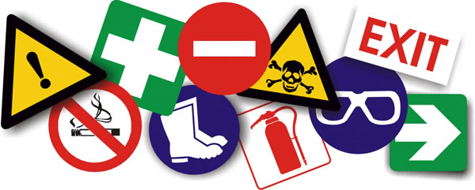
Name: _______________________________ Department: _______________________________
What is the location of the nearest First Aid kit in your department?

Every Department is required to have or share a Department Safety Bulletin Board according to OHSA. What is the location of your department’s Safety Bulletin Board?
Include building name, floor or room.
Name 2 items posted on your Departmental Safety Board.
What is the name of your Department Safety Officer? Hint: ask around, check your Safety Board or the EHS webpage for Safety Officers list.
What is the name of the Report to use if someone is hurt in the course of work?
What is the only training topic provided by Environmental Health and Safety that is MANDATORY for every employee? Hint: www.queensu.ca/risk/safety/training
From the Resource Index webpage, name any Procedure (SOP) under the Environmental Health & Safety section that has applied to you at any time.
If your role requires WHMIS training, how frequently do you need to complete the Refresher?
What does OCASP stand for?

How many JHSCs are there at Queen’s?
Bonus:
Which JHSC does your department belong to?
What is the location of the nearest Automated External Defibrillator (AED)? Hint: https://www.queensu.ca/risk/safety/general

