Building Name: Botterell Hall  Room Number: 402 |  |  | 
 | 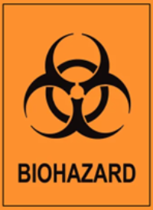
 | CL1
Hazard Type | Additional Information
Biohazard | Human Cell Lines and Blood
PPE REQUIRED
 |  |  |  |  |  |  | 
Additional PPE requirements: None
EMERGENCY CONTACT INFORMATION
Role |  | Name |  | Phone number |  | Office Rm #
PI |  | Raico |  | 613 |  | 101
Lab Manager |  | Nat |  | 613 |  | 102
Professor
Lab Tech
EHS Contact Info: Raico Lamela (BSO & RSO) 613-533-6000 x78820 | Natalie Roy (Safety Tech) 613-533-2951 | Tom Martinek (Safety Tech) 613—533-6000 x74976 | General Safety 613-533-2999

