Building Name: Botterell Hall  Room Number: 402 |  |  | 
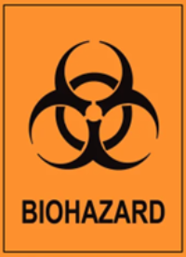 | 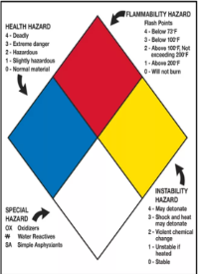 | 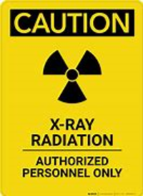
CL2 | Flammables | High-Level
Hazard Type | Additional Information
Biohazard | Human Cell Lines & Blood
Chemical | EtOH
Radiation | X-ray device
PPE REQUIRED
 |  |  |  |  |  |  | 
EMERGENCY CONTACT INFORMATION
Additional PPE requirements: Lead apron only required when Xray is in use
Role |  | Name |  | Phone number |  | Office Rm #
PI |  | Natalie Roy |  | 613-217-1956 |  | EHS Rm. 101
Lab Manager |  | Raico Lamela |  | 613-533-6000 x78820 |  | EHS Rm. 104
Professor
Lab Tech
EHS Contact Info: Raico Lamela (BSO & RSO) 613-533-6000 x78820 | Natalie Roy (Safety Tech) 613-533-2951 | Tom Martinek (Safety Tech) 613—533-6000 x74976 | General Safety 613-533-2999

