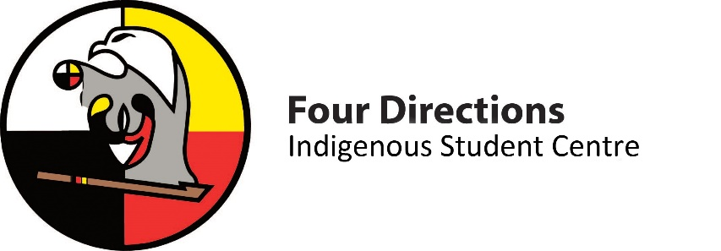
Four Directions Indigenous Student Centre

Position: Indigenous Peer Mentor
Term: September 1st 2021 – April 30th 2022
Remuneration: N/A (volunteer position)

Background:
Four Directions Indigenous Student Centre (FDISC) strives to be a home away from home for Indigenous students. FDISC provides holistic support (emotional, physical, spiritual, and mental) to Indigenous students at Queen’s University by offering cultural counselling, academic advising, support services, feasts, social, and cultural activities.
First year transition to university can be, for some students, a challenging time. The Indigenous Peers program matches upper-year Indigenous students with first year Indigenous students. This provides first year Indigenous students with the opportunity to learn from an upper-year Indigenous student who can share their experiences of being a first year student and how they successfully completed one or more academic years at Queen’s U. The goal of the program is to assist students in navigating the transition and developing skills needed to be successful at university. Indigenous peer mentors form meaningful relationships and promote wellbeing for Indigenous students.
Key Duties:
- Build a positive relationship and rapport with Indigenous students and staff;
- Serve as an energetic and enthusiastic mentor to support first year Indigenous students in navigating the post-secondary environment;
- Act as a positive role model (i.e. model effective problem solving skills, academic study skills, and self-care strategies to mentees);
- Develop and maintain a confidential and trusting relationship with your mentee to assist and support them;
- Be a resource to mentees and refer them to appropriate campus resources, when necessary;
- Help facilitate and encourage attendance at the FDISC and other social programming;
- Represent FDISC within the Queen’s community, Indigenous community, and the larger community at events, on social media, and during recruitment opportunities;
- Co-plan and co-facilitate social events for mentors and mentees either in person or virtually;
- Co-facilitate a Microsoft Teams or social media group for mentors and mentees to stay connected;
- Report to, and work closely with, the Indigenous Student Advisor to ensure connection with FDISC;
- Maintain records of one-on-one meetings with mentees for reporting purposes;
- Participate in training, programs, and activities;
- Conduct yourself according to the Queen’s Academic Integrity Policy (https://www.queensu.ca/academicintegrity/home);
- Conduct yourself according to the Queen’s Student Code of Conduct (http://www.queensu.ca/secretariat/sites/webpublish.queensu.ca.uslcwww/files/files/policies/senateandtrustees/Code_of_Conduct_final_2008.pdf); and
- Other duties as assigned.
Skills Required:
- Possess an interest, passion, and enthusiasm for supporting other Indigenous students;
- Conduct self in a respectful, non-judgmental, and supportive manner;
- Demonstrate leadership potential;
- Possess excellent time management and organizational skills;
- Effective open and on-going communication and interpersonal skills;
- Maintain confidentiality with student information at all times;
- Familiarity with on-campus services such as SASS, Student Wellness Services, Career Services, Division of Student Affairs, and embedded faculty resources;
- Proficient in Microsoft Office applications (Excel, Outlook, Word, and PowerPoint); and
- Experience and comfortability with creating and sharing social media posts (written, images, and videos).
Eligibility:
- Full-time equivalent Queen’s undergraduate or graduate student with at least one year experience as a Queen’s student;
- Must have Indigenous ancestry and demonstrated connection with an Indigenous community and other Indigenous networks; and
- Good academic and student conduct standing.
Time Commitment:
- Minimum of one meeting per week with Indigenous Advisor and other Indigenous Peer Mentors;
- Approximately one meeting or virtual communication (i.e. email) peer week with mentee;
- There are no set hours per week for this position, as time commitments may fluctuate based on the timeline of events/programs and communication with mentees based on their needs; and
- The volunteer term will be September 2020 to April 2021.
Benefits:
- Build meaningful relationships with other Indigenous students, FDISC staff, and campus partners;
- Develop and practice critical workplace skills; and
- Give back to the Indigenous student community on campus.

Questions can be directed to Jessica Parks, Indigenous Advisor, via email at jessica.parks@queensu.ca
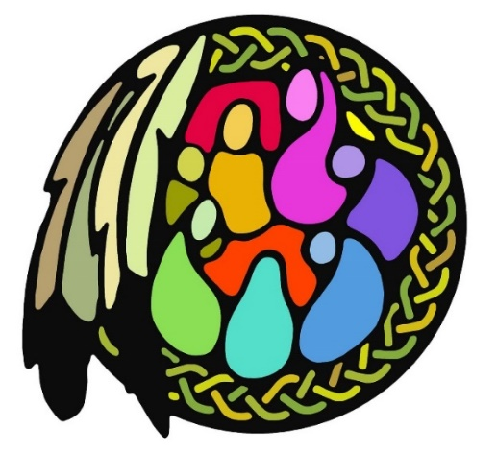
We are committed to employment equity and diversity in the workplace and welcome applications from individuals from equity seeking groups such as women, racialized/visible minorities, Indigenous/Aboriginal peoples, persons with a disability, persons who identify in the LGBTQ2S+ community and others who reflect the diversity of Canadian society.

