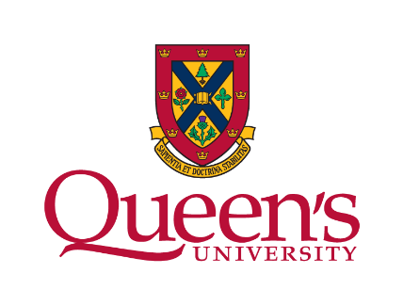
Workshop Evaluation Questionnaire

Session Name: ______________________________
Date: ______________________________________

Please mark an X to indicate your response to the following statements.
Statement | Strongly Disagree | Disagree | Neither Agree nor Disagree | Agree | Strongly Agree
The workshop objectives were clear to me

This workshop covered the objectives well

The content was relevant to my job

The workshop activities were engaging and enhanced my learning
The activities allowed me to practice, develop and improve my skills
The difficulty level of the workshop was appropriate

The facilitator was well prepared

The facilitator was a good communicator

The facilitator answered questions and was helpful

I will be able to use what I learned in this workshop

What is one thing that you learned about in the workshop that you can apply in your role or studies?
_________________________________________________________________________________________________________________________________________________________________________________________________________

What is one thing that we could do to improve future workshops of this nature?
_________________________________________________________________________________________________________________________________________________________________________________________________________

