Ion Exchange Membranes: Protocol

Written by Nishka (Veronika) Wright, M.Sc. Candidate
June 2015

See also Qian Gu’s 2020 paper ‘Nutrient availability measurement techniques in arctic
tundra soils: in situ ion exchange membranes compared
to direct extraction’ in Plant and Soil and the supplemental files for follow-up

IEM suppliers:
- SUEZ Water Technologies & Solutions, USA) - large sheet forms (18.25 cm x 40.25 cm) in two different types: cation exchange membranes (CEMs, ID: CR67HMR) and anion exchange membranes (AEMs, ID: AR204SZRA)
- Membranes International, New Jersey, USA
- Durpro: 1-450-659-7781; Corey: 1-289-218-9323

- Cutting IEMs:

Materials:
- Gloves (wear at all times)
- Lab coat
- IEM sheets
- Permanent marker
- Exacto knife (make sure it is clean!)
- Ruler

Keep the IEM sheets in the plastic – use clothespins to keep them together. Using a ruler measure out 10 x 5cm and 10 x 10 cm sections (Fig.1). Cut them out with a clean Exacto knife while the IEMs are still in the plastic. Finish one sheet at a time. Make sure you cut cation and anion sheets separately and thoroughly clean the Exacto knife between cutting both kinds of sheets. Ensure IEM sheets and cut-our strips are kept moist throughout the whole process by placing cut strips into distilled water (2 L). DO NOT MIX CATION AND ANION SHEETS TOGETHER! Shake each strip in distilled water in a plastic container. Store these sheets in a sealed plastic bag with a few drops of distilled water in the fridge.
B
A
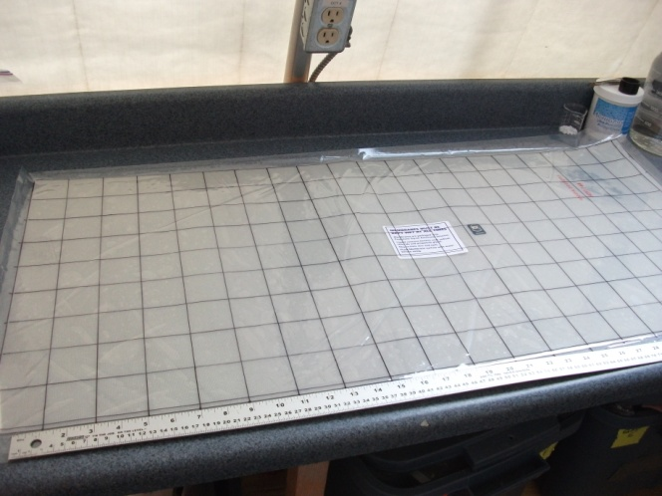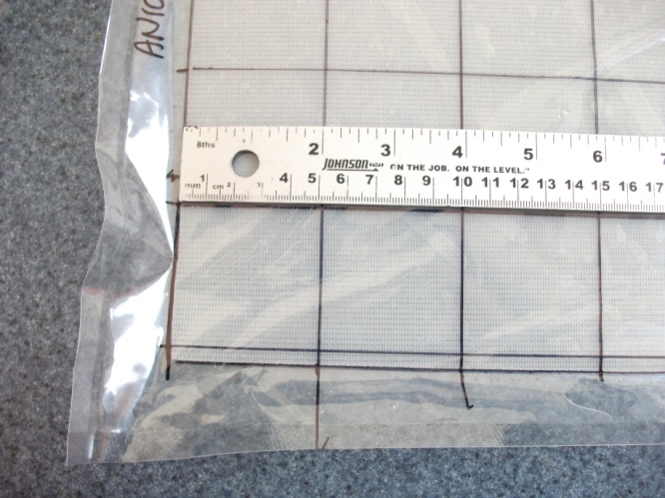
Fig. 1: (A) Drawing on the plastic covering the IEMs with permanent marker and (B) a close-up of the measurements.

- Charging cation sheets

Materials:
- Gloves (wear at all times)
- Lab coat
- 3 plastic containers with lids - made of polypropylene (PP) or high density polyethylene (HDPE)
- Large Ziplock bags
- 0.5 M (mol/L) HCl
- Cut cation IEM strips
- Distilled water

Take IEM strips from the plastic bag (or from the distilled water container if cutting and charging at the same time). Pour 1.5 L of 0.5 M HCl (comes as a solution already) into a plastic container. Make sure that the IEMs are covered by the solution (strips may float). Place the lid on the container and gently shake the container for 10 min with the bottom of the container resting on the table. After, check that all IEM strips are covered by the HCL solution and let the strips sit for one hour. During this hour, prepare two other containers: one container will hold 1.5 L distilled water and the other will hold 1.5 L of fresh 0.5 M HCl. Rinse each IEM strip in distilled water and then place it in the fresh HCl container. Once all the strips are in that HCl container, put on the lid, shake it gently for 10 mins and let it sit for one hour. Meanwhile, empty the used HCl container and fill it with 1.5 L of fresh 0.5 M HCl, and replace the used distilled water with fresh distilled water. Rinse the strips in that fresh distilled water and then transfer them to the third (fresh HCl) bath. Again, replace the used distilled water with fresh distilled water. After one hour, rinse each IEM strip in fresh distilled water as before. Store IEMs in a sealed Ziplock bag in the fridge.

Note: Prepare Blanks
Each time that your charge IEMs, make sure that you have 2 additional strips to use as blanks. Charge them with the other IEMs and then store them in the fridge until you extract the IEMs from the field. These blanks can be used to test for potential contamination from the charging solutions, or their containers, or the elution solutions or their containers, or the bags in which the IEMs are stored. And secondly, the blank value in the final nutrient analysis reflects the background spectrophotometer absorption associated with the chemical analysis system which is then subtracted from the sample absorption values to calculate the final data.

- Charging anion sheets

Materials:
- Gloves (wear at all times)
- Lab coat
- 3 plastic containers with lids - made of polypropylene (PP) or high density polyethylene (HDPE)
- Large Ziplock bags
- 0.5 M (mol/L) NaHCO₃ (sodium bicarbonate)
- Cut anion IEM strips
- Distilled water

Take IEM strips from the plastic bag (or from the distilled water container if cutting and charging at the same time). Pour 1.5 L of 0.5 M NaHCO₃ (comes as a solid so we will need to make the 0.5 M solution) into a plastic container. Make sure that the IEMs are covered by the solution (strips may float). Some fizzing and bubbling from the immersed membranes is commonly observed, but not considered a problem. Place the lid on the container and gently shake the container for 10 min with the bottom of the container resting on the table. After, check that all IEM strips are covered by the NaHCO₃ solution and let the strips sit for one hour. During this hour, prepare two other containers: one container will hold 1.5 L distilled water and the other will hold 1.5 L of fresh 0.5 M NaHCO₃. Rinse each IEM strip in distilled water and then place it in the fresh NaHCO₃ container. Once all the strips are once again in the NaHCO₃ container, place the lid on the container, shake it gently for 10 mins and let it sit for one hour. Meanwhile, empty the used NaHCO₃ container and fill it with 1.5 L of fresh 0.5 M NaHCO₃, and replace the used distilled water with fresh distilled water. Rinse the strips in that fresh distilled water and then transfer them to the third (fresh NaHCO₃) bath. Again, replace the used distilled water with fresh distilled water. Store IEMs in a sealed Ziplock bag in the fridge. Please see appendix for calculations for making the 0.5 M NaHCO₃ solution.

- Inserting IEMs (in situ)

Materials:
- Gloves (wear at all times)
- Permanent marker
- IEM strips
- Sewing needle
- Fishing line
- Flagging tape

Prior to heading out into the field – use a sewing needle to pierce the corner of each IEM strip (Fig. 2) – don’t forget to do this for the blanks as well! (Note: sew cation and anion strips separately and wash the materials very well in between.) Thread fishing line through the hole.
B
A

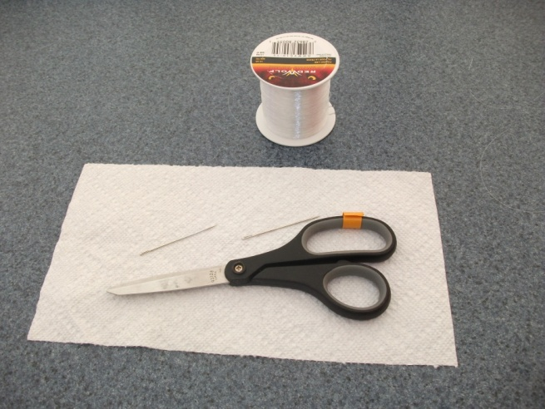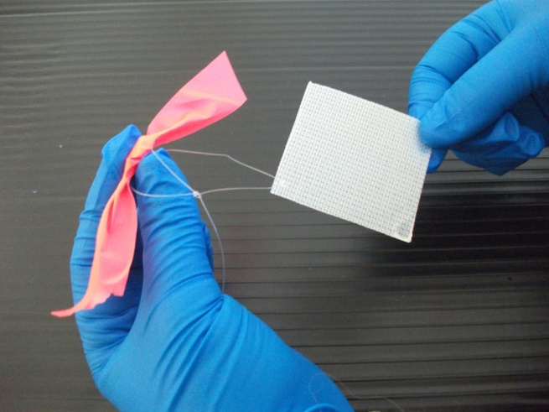
Fig. 2: (A) Equipment needed to sew IEMs; (B) an IEM with a loop of fishing line for retrieval and flagging tape so it can be found in the field.

Place IEM strips in a plastic bag in a portable cooler. Ensure that the IEM strips do not directly touch the ice packs. Using a wood chisel (which is about 5 x 5 cm) cut a 5 x 5 cm slit in the ground. Slip the IEM inside the slit. Ensure that they entire IEM is covered with soil to ensure that it will not dry out. Tie flagging tape (pink for cation and orange for anion) to each loop of fishing line. DO NOT LABEL THE IEM DIRECTLY. Step on the IEM to ensure that it is pressed against the soil (Fig.3).
C
B
A
C
A

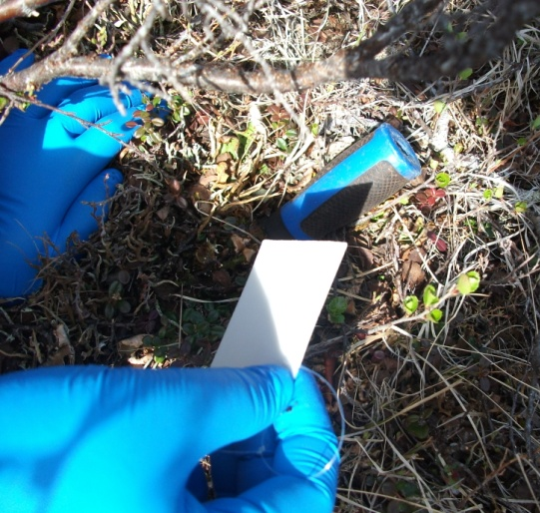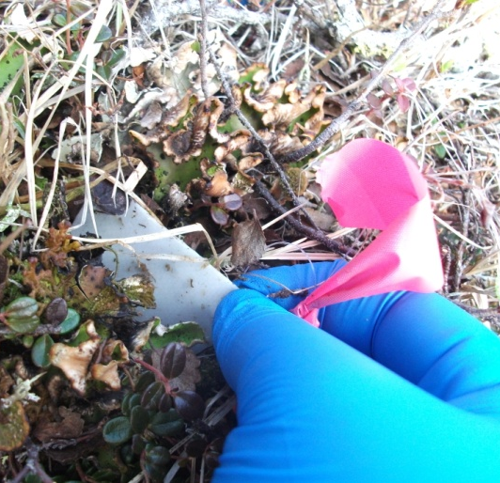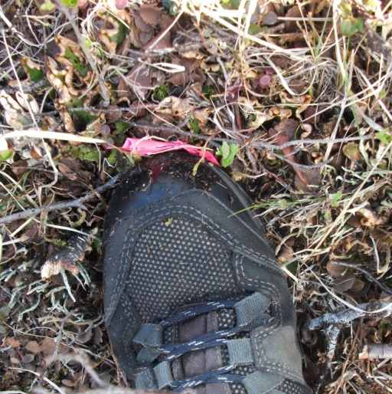
Fig.3: (A) Chisel creating a slit in the organic layer; (B) inserting the IEM into the slit; and (C) packing down the soil to secure the IEM.

- Retrieving & Preserving IEMs (in situ)

Materials:
- Gloves (wear at all times)
- Permanent marker (to rewrite labels if some have rubbed off)
- New Ziplock bags
- Distilled water in a squirt bottle

Prelabel the Ziplock bags for efficient retrieval and prepare a portable cooler with ice packs at the bottom of the cooler. IEMs may come into contact with ice packs upon retrieval. Retrieve IEMs in the same order in which they were inserted.

Gently tug on the fishing line and remove IEM while wearing gloves (Fig.4). Rinse the IEM with distilled water in a squirt bottle. Squirt enough water to remove large soil particles and vegetative pieces. Now place the IEM into the appropriate Ziplock bag.

Upon return from the field, place all IEMs (including the blanks that are in the fridge) into the freezer. All extractions will be done in Kingston. In hindsight, it would have been better to also rinse the blanks with DI water to account for any contamination from the water itself.
B
A
D

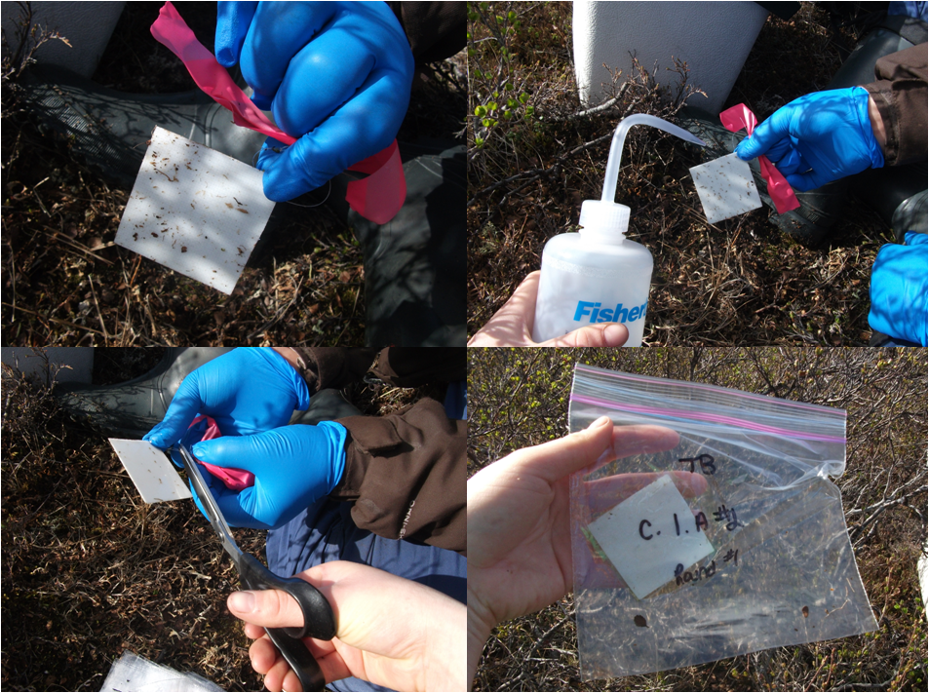
C
Fig.4: (A) An IEM that has just been removed from the organic layer; (B) IEM rinsed with water; (C) cutting the fishing
line and flagging tape from the IEM; (D) IEM stored in prelabelled Ziplock bag.

- Loading IEMs (ex situ): the procedure described in this section was used to test the efficiency of nutrient uptake and release by the IEMs, and that data is reported in Gu (2020)
C
B
Materials:
- Gloves (wear at all times)
- Standards (0.04, 0.02, 0.1, 0.5, 2.5 ug/L) x 3 reps
- Blanks (Ultra Pure water from room 2606)
- 18 clean Petri dishes
- 6 clean graduated cylinders (25 ml)
- Elastic bands
- Shaker table
- Charged IEMs (cation or anion) – 5cm x 5cm

First, set up a zone where the solutions will be poured by laying down some bench coat and a splash pad. Wear all PPE: a lab coat, gloves and goggles. Place two membranes (cation OR anion, but not both) into each clean Petri dish (i.e. replicate) that is needed (e.g. n = 18). Label the Petri dishes according to treatment. At random, pour 25 ml of each standard (Table 1) into each Petri dish. Once complete, put the lid on and slip an elastic band to help keep the lid and dish together.
Table 1: Concentrations used to test membrane exchange capacity of nutrients of interest.
Nutrient: | Stock Conc: | Trt 1: | Trt 2: | Trt 3: | Trt 4: | Trt 5:
NH₄⁺ | Using: (NH₄)₂SO₄  Stock: 2.5NH₄-N mg/L  11.798 mg (NH₄)₂SO₄ in 1L | 0.004mg/L or  4 ug/L | 0.02 mg/L or  20 ug/L | 0.1 mg/L or  100 ug/L | 0.5 mg/L or  500 ug/L | 2.5 mg/L or 2500 ug/L
NO₃⁻ | Using: KNO₃  Stock: 2.5 NO₃-N mg/L  18.036 mg KNO₃ in 1L | 0.004mg/L or  4 ug/L | 0.02 mg/L or  20 ug/L | 0.1 mg/L or  100 ug/L | 0.5 mg/L or  500 ug/L | 2.5 mg/L or 2500 ug/L
PO₄³⁻ | Using: KH₂PO₄  Stock: 2.5PO₄-P mg/L  10.968 mg KH₂PO₄ in 1L | 0.004mg/L or  4 ug/L | 0.02 mg/L or  20 ug/L | 0.1 mg/L or  100 ug/L | 0.5 mg/L or  500 ug/L | 2.5 mg/L or 2500 ug/L

Now, place the Petri dishes randomly on the shaker table located in room 2605 (across the hall from the main lab) (Fig.5). You will likely need to layer the samples and this can be done using the rubber materials found on the shelves above the shaker table. With this materials and the elastic bands, the Petri dishes are more apt to remain upright and on shaker table.
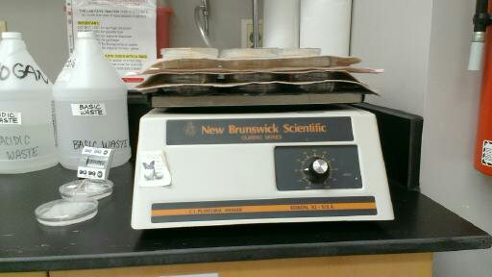
Fig.5: The shaker table in room 2605 with four layers of sample and a perforated cloth between layers to keep the samples in place. Note this shaker table has now been replaced with a similar one that has a digital screen.
Once you are satisfied that the samples are secure, turn the shaker table on at a speed of about 48 r.p.m. (any higher and your samples will spill). To sufficiently load the membranes, they should be shaken on this table for 20 hours. After 20 hours, pour the solution into a waste container and put the membranes into a new and clean Petri dish for immediate elution (see below for instruction).

- Eluting IEMs (in situ or ex situ samples)

Materials:
- Gloves (wear at all times)
- Eluting solution (One solution 2M NaCl in 0.1 M HCl was since found to be the ideal for extracting/eluting both anions and cations... See Gu 2020). Stock: 8.4 ml of conc HCl made up to 1 L with distilled water; Weigh out 116.88 g NaCl and make up to 1 L with 0.1M HCl stock.
- 18 clean Petri dishes
- 2 clean graduated cylinders (25 ml)
- Elastic bands
- Shaker table
- Sample IEMs – 5 cm x 5 cm
- Ziplock bags

First, set up a zone where the solutions will be poured by laying down some bench coat and a splash pad. Wear all PPE: a lab coat, gloves and goggles. Place sample IEMs into a clean Petri dish labelled according to treatment. Pour 25 ml of eluting solution into each Petri dish (Table 2), and slip an elastic band around the dish and corresponding lid. Note Qian Gu (2020) used smaller volumes (Author correction to the published paper indicates 5 ml per membrane were used) , but it seems at least 20 ml is necessary to fully immerse two membranes, and 25 ml for three membranes. If you are eluting more samples together, try eluting 10 membranes (5cm x 5cm) in 80 ml of solution in the comparatively larger, sandwich containers.

Table 2: Solutions used for charging and eluting membranes.
Membrane: | Charging: | Eluting: | Nutrient(s):
Cation | 0.5 M HCl | 2M NaCl in 0.1 M HCl | NH₄⁺
Anion | 0.5 M NaHCO₃ | 2M NaCl in 0.1 M HCl | NO₃⁻ and PO₄³⁻

Now, place the Petri dishes on the shaker table located in room 2605 (across the hall from the main lab) (Fig.5). You will likely need to layer the samples and this can be done using the rubber materials found on the shelves above the shaker table. With this materials and the elastic bands, the Petri dishes are more apt to remain upright and on shaker table.
Once the samples are secure, elute them for two hours (with dial positioned at ~48 r.p.m.). After this time, pour the solution into the appropriate waste container. Preserve the eluted membranes in labelled Ziplock bags and freeze them (as a precaution). Set-up Erlenmeyer flasks with Buchner funnels and 1.2 um Fisher G4 fiber filter paper. Pour the solution into the Buchner funnel to filter the sample and ensure that no particles (i.e. soil) are left in the sample. Pour the sample from the Erlenmeyer flask into scintillation vials for storage. You may freeze them if necessary.
Note: Need to add some indication of how to handle the waste chemicals appropriately. I suspect the charging solutions should be treated as hazardous waste but I think the elution solution is probably weak enough to go down the sink - we need to check with EH&S just in case it should be treated as hazardous.

